Assessment 3 Web Application Security Assessment Report

Prepared for Charles Bank

Group Number: ECP Group 1
Musrat Jahan (S380098)
Meetkumar Dharmeshbhai Savaliya (S382825)

Contents
Assessment 3 Web Application Security Assessment Report 1
Prepared for Charles Bank 1
Group Number: ECP Group 1 1
Executive Summary 4
Technical Summary 5
Scope 5
Key Findings 5
Key Recommendations 5
Findings and Recommendations 6
Findings 6
1. SQL Injection (UNION-Based in Transaction Search) 6
2. SQL Injection in Transaction Search 8
3. SQL Injection in Transaction Search 11
4. SQL Injection Database Error Disclosure in Transaction Search 12
5. SQL Injection and Database Error Disclosure in Login 17
6. Stored Cross-Site Scripting (XSS) in message 20
07. Reflected Cross-Site Scripting (XSS) in Transaction Search 22
8. Cross-Site Scripting (XSS) in Transaction Search 24
09. Race Condition in Fund Transfer 26
10. Authentication (Weak Password Policy During Account Registration) 28
11. Authentication (Improper Username Input Validation During Registration) 30
12. Authentication (Missing Account Lockout Protection Against Repeated Failed Login Attempts) 32
13. Authentication Bypass Due to Password-Only Login Validation 33
14. Authentication (Multiple Accounts Can Use the Same Weak Password) 35
15. Authentication Bypass Through Shared Password Matching 37
16. Authorization (Unauthorized Access to Other Users’ Transactions details via URL Manipulation) 39
17. Authorization (Unauthorized Access to Other Users’ Messages via URL Manipulation) 41
18. Business Logic (Negative Value Processing in Fund Transfer) 43
19. Business Logic (Incorrect Balance Calculation) 44
20. Business Logic (Integer Overflow and Improper Input Validation in Transaction system) 46
21. Business Logic(Improper Input Validation in Loan system) 49
22. Session Management (Improper Session Handling and Access to login Pages While Logged In) 52
23. Session Management (Session Persistence Across Browser Windows) 55
24. Directory Traversal 57
Appendices 59
Appendix A – Risk Matrix 59
Appendix B – Finding 22 Integer Value finding pattern 59
Appendix C – Grammerly 60
Appendix D – Turnitin 60
References: 61

Executive Summary
A penetration testing assessment was conducted on the Charles Bank website to identify security vulnerabilities affecting customer data, authentication, transactions, and banking operations. The testing used a black-box approach from both authenticated and unauthenticated user perspectives with tools such as Burp Suite.
The assessment identified multiple critical and high-risk vulnerabilities, including SQL Injection, Cross-Site Scripting (XSS), Race Condition, Broken Authentication, Broken Access Control (IDOR), weak session management, and business logic flaws in transaction and loan processing system.
Several vulnerabilities allowed unauthorized access to user accounts, viewing of other users’ transactions and messages, and execution of malicious scripts. In short, the application has a high security risk. Immediate fixes are needed to improve authentication, input validation, access control, and transaction security to prevent unauthorized access and financial manipulation.

Name | Task | Contribution
Musrat Jahan | Test and report | 50%
Meet Savaliya | Test and report | 50%

Technical Summary

Scope
This penetration testing assessment was conducted on the Charles Bank website hosted in a testing environment. The assessment used a black-box testing approach from both authenticated and unauthenticated user perspectives.
The scope of testing included:
- User registration and login functionality
- Authentication and session management
- Fund transfer and transaction processing
- Transaction search functionality
- Loan system and Messaging system
- Input validation and business logic controls
- Access control and authorization
- Database interaction and error handling
The assessment focused on identifying vulnerabilities that could impact the confidentiality, integrity, and availability of the banking website and customer data.

Attribute | Value
IP / Hostname | https://a992652e929e9955.prt574exam.cloud/
Testing Type | Black Box, Manual
User | Musrat, Mus, Rat, MusTest, Jahan, Test, Meet, Archie

Key Findings
- SQL Injection vulnerabilities detected.
- Stored and Reflected XSS vulnerabilities identified.
- Weak authentication and password security controls.
- Missing account lockout protection.
- Session management weaknesses present.
- Race condition vulnerability in fund transfer.
- Business logic flaws in transaction processing.
- Unauthorized access to user data through URL manipulation (IDOR).
- Improper input validation across multiple functions.
- Directory Traversal vulnerability identified.

Key Recommendations
- SQL Injection: Use parameterized queries.
- XSS : Validate and encode inputs.
- Business Logic : Add server-side validation.
- Race Condition : Use transaction locking.
- Path Traversal: Restrict file paths.
- Session Management : Use secure sessions with expiry.

Findings and Recommendations

Findings

1. SQL Injection (UNION-Based in Transaction Search)
Risk: Critical | Likelihood: Very Likely | Consequence: Major
Description
The Charles Bank transaction search functionality is vulnerable to UNION-Based SQL Injection due to improper input validation. During testing, multiple UNION SELECT payloads were entered into the search field, and the system returned database table names from the SQLite sqlite_master table.
The following table names were displayed under the # column:
- loans
- messages
- transactions
- users
The website also showed manipulated values in other columns.
Impact
An attacker can:
Access database structure and tables
Steal sensitive data like usernames, balances, and transactions
Perform further SQL injection attacks
Potentially compromise the entire database
This can lead to data theft, unauthorized access, and financial fraud.
Evidence
Evidence 1: 1’) UNION SELECT name,2,3,4,5,6,7 FROM sqlite_master WHERE type='table'--
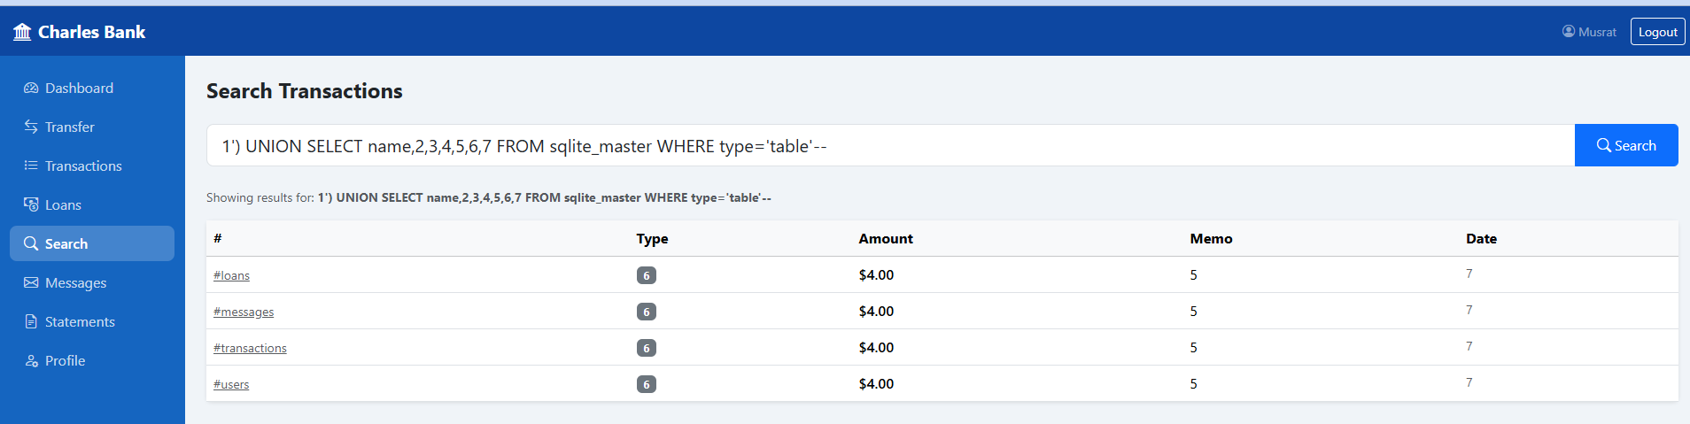

Evidence 2: 1’) UNION SELECT 1,2,3,4,name,6,7 FROM sqlite_master WHERE type='table'--

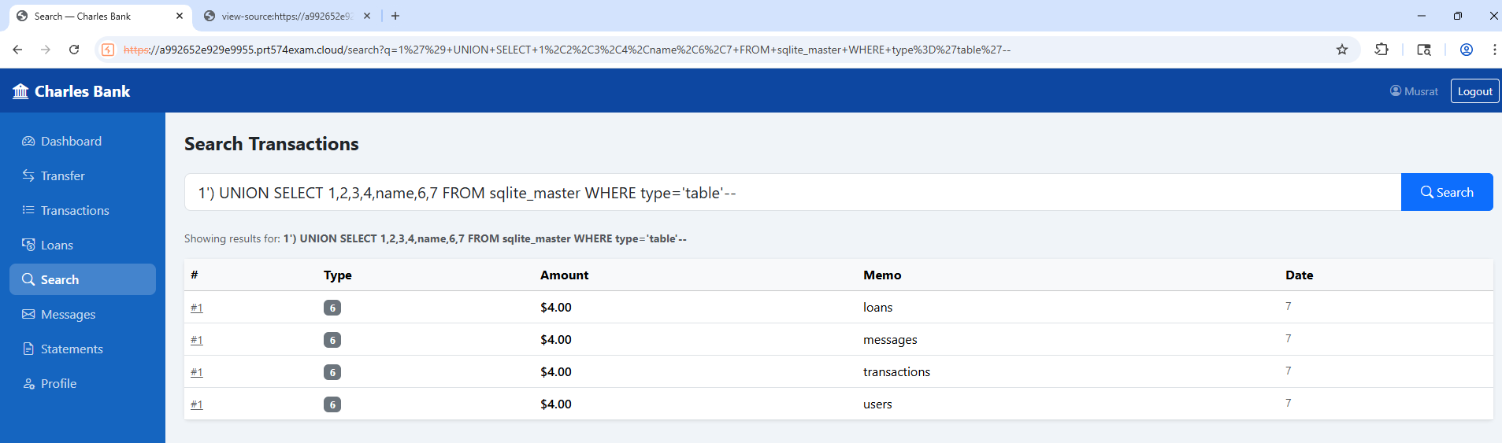

Evidence 2: 1’) UNION SELECT 1,2,3,4,5, name,7,8 FROM sqlite_master WHERE type='table'—

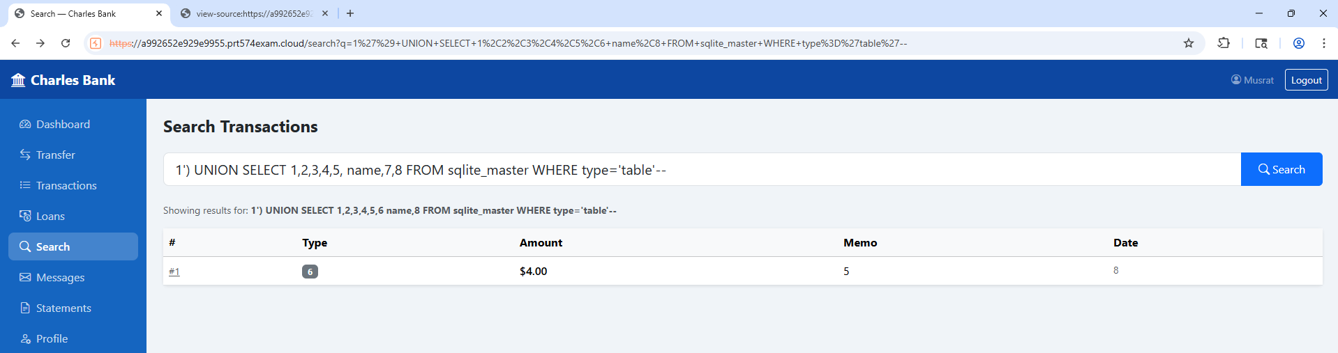
Evidence 4: BurpSuite

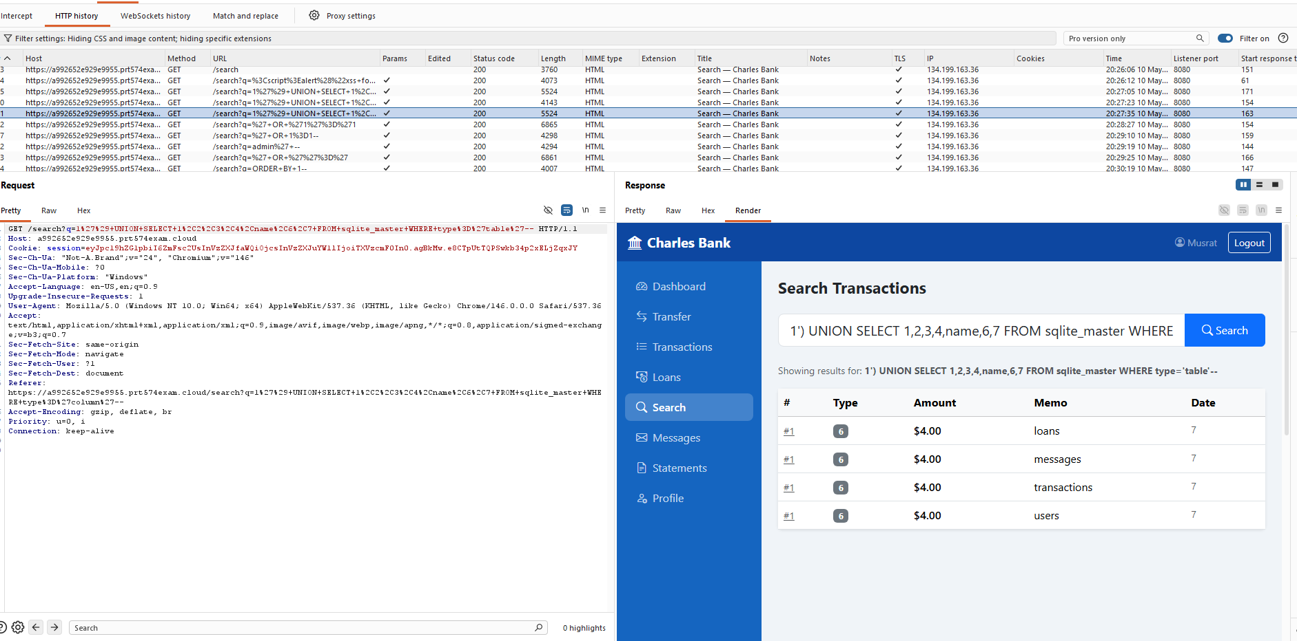

Actions taken
- Logged into the Charles Bank website using a valid account
- Opened the transaction search functionality
- Entered multiple UNION SELECT SQL payloads into the search field
- Submitted the payloads and observed database table names in the results
- Verified differences in output based on column positioning
References : UNION-Based SQL Injection

2. SQL Injection in Transaction Search

Risk: Critical | Likelihood: Very Likely | Consequence: Major
Description
The Charles Bank transaction search functionality is vulnerable to SQL Injection due to improper input validation. During testing, the following payload was entered into the transaction search field:
- ' OR '1'='1
- 'OR"='
After submitting the payload, the website returned multiple unrelated transaction records instead of filtering results normally. The output included transaction details.
The returned records included approximately: 2 loan transactions & 6 transfer transactions.
Impact
An attacker can:
- Bypass search restrictions
- Access unauthorized banking data
- View sensitive financial information
- Manipulate SQL queries
- Extract more database data
This may lead to data breaches, financial fraud, and full system compromise..

Evidence
Evidence 1: ' OR '1'='1
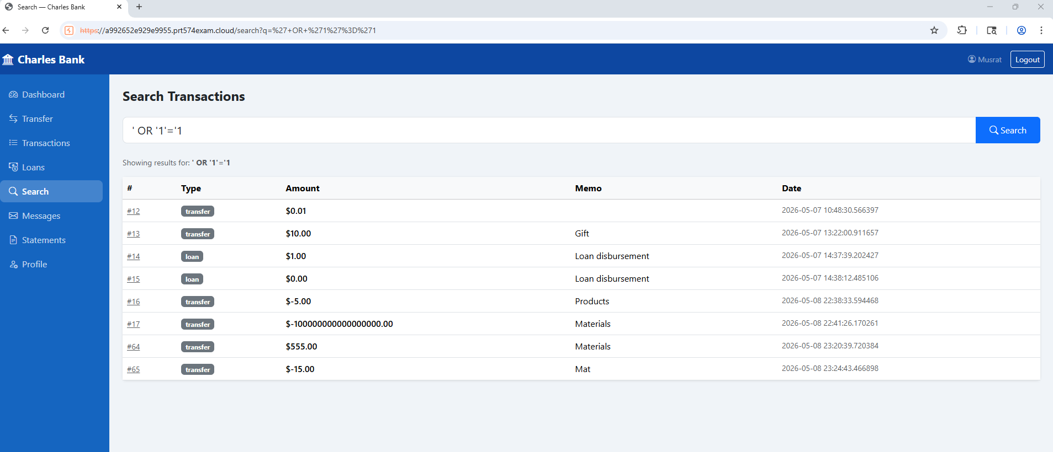
Evidence 2: Burp Suite

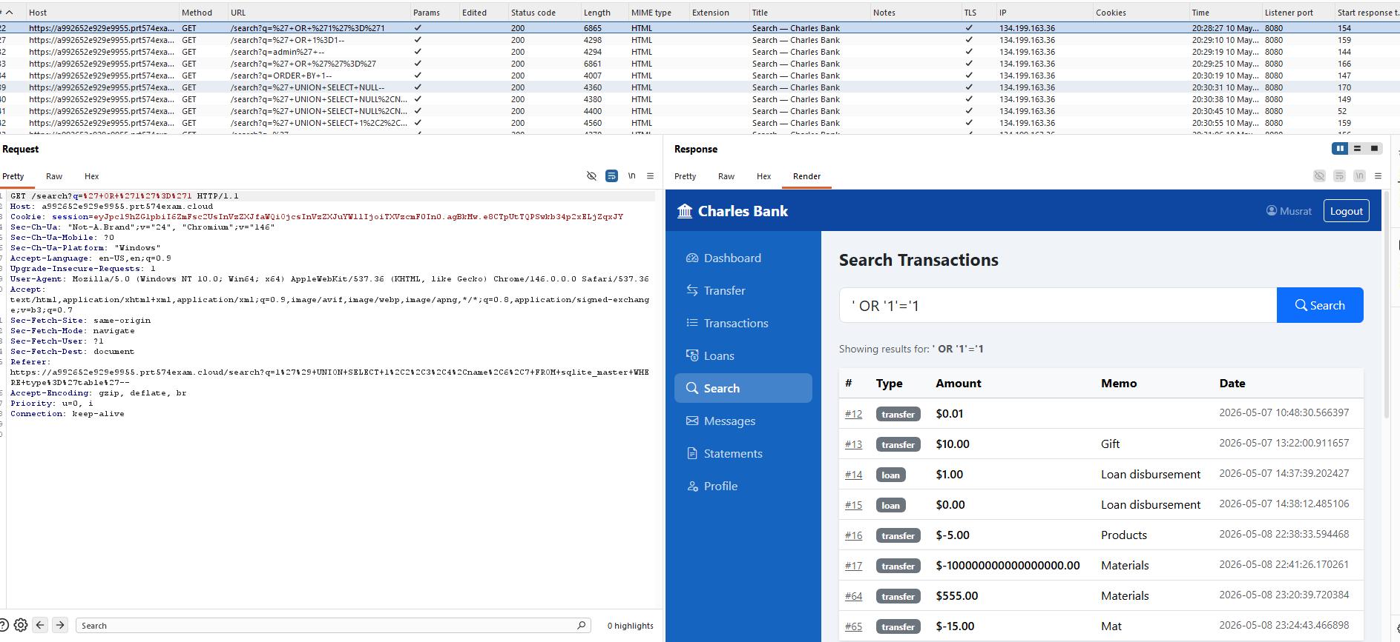

Evidence 3: ' OR "='
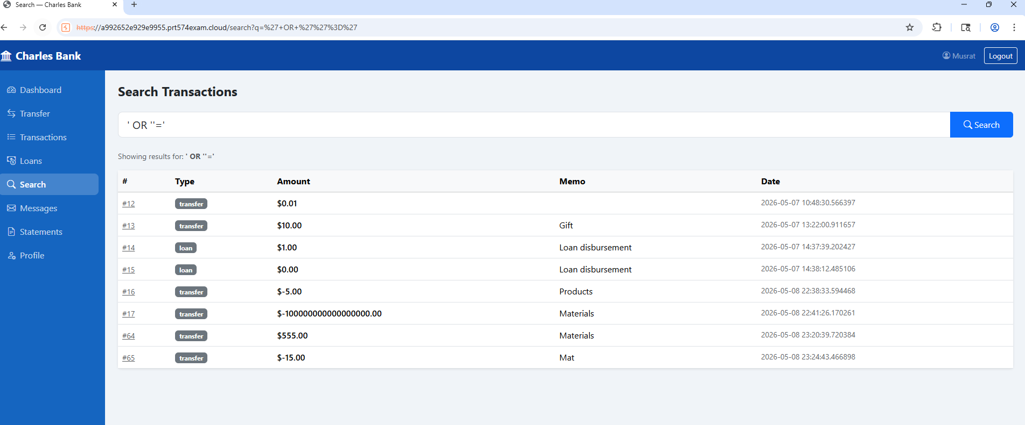
Evidence 3: ' OR "=' Burp Suite

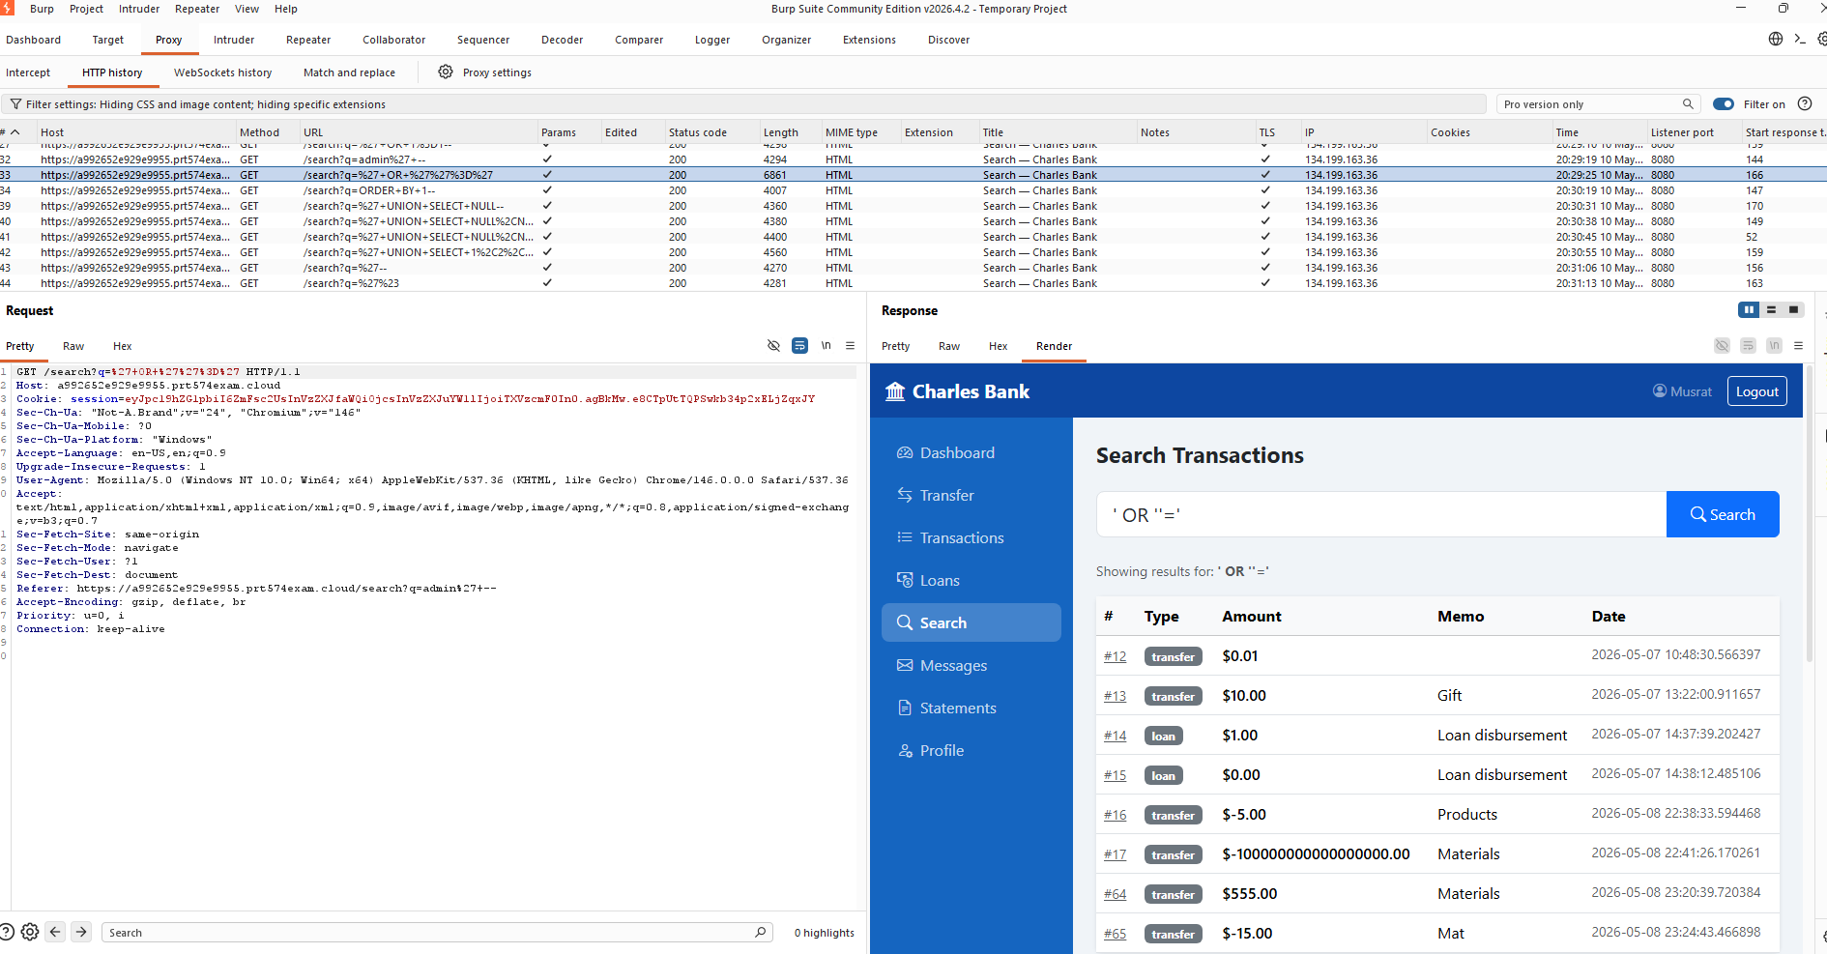
Actions taken
- Entered the payload: ' OR '1'='1 & 'or "=' in the transaction search page.
- Submitted the search request.
- Observed that multiple unrelated transaction records were displayed.
References: SQL Injection

3. SQL Injection in Transaction Search

Risk: Critical | Likelihood: Very Likely | Consequence: Major
Description
The Charles Bank transaction search functionality is vulnerable to SQL Injection due to improper input validation. During testing, the following payload was entered into the transaction search field:
- '||'test
After submitting the payload, the system returned transaction details including:
Type: transfer, Amount: $0.02, Memo: test, Date: 2026.05.10.
Impact
An attacker could:
- Manipulate SQL queries
- Bypass search restrictions
- Access sensitive transaction data
- Discover database structure
- Perform SQL injection attacks
- Read or modify database records
This may lead to unauthorized access to customer and financial information.
Evidence
Evidence 1: '||'test
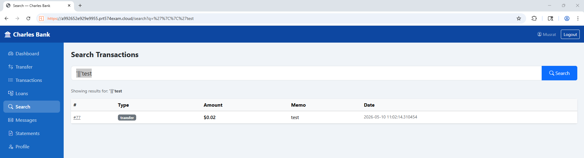

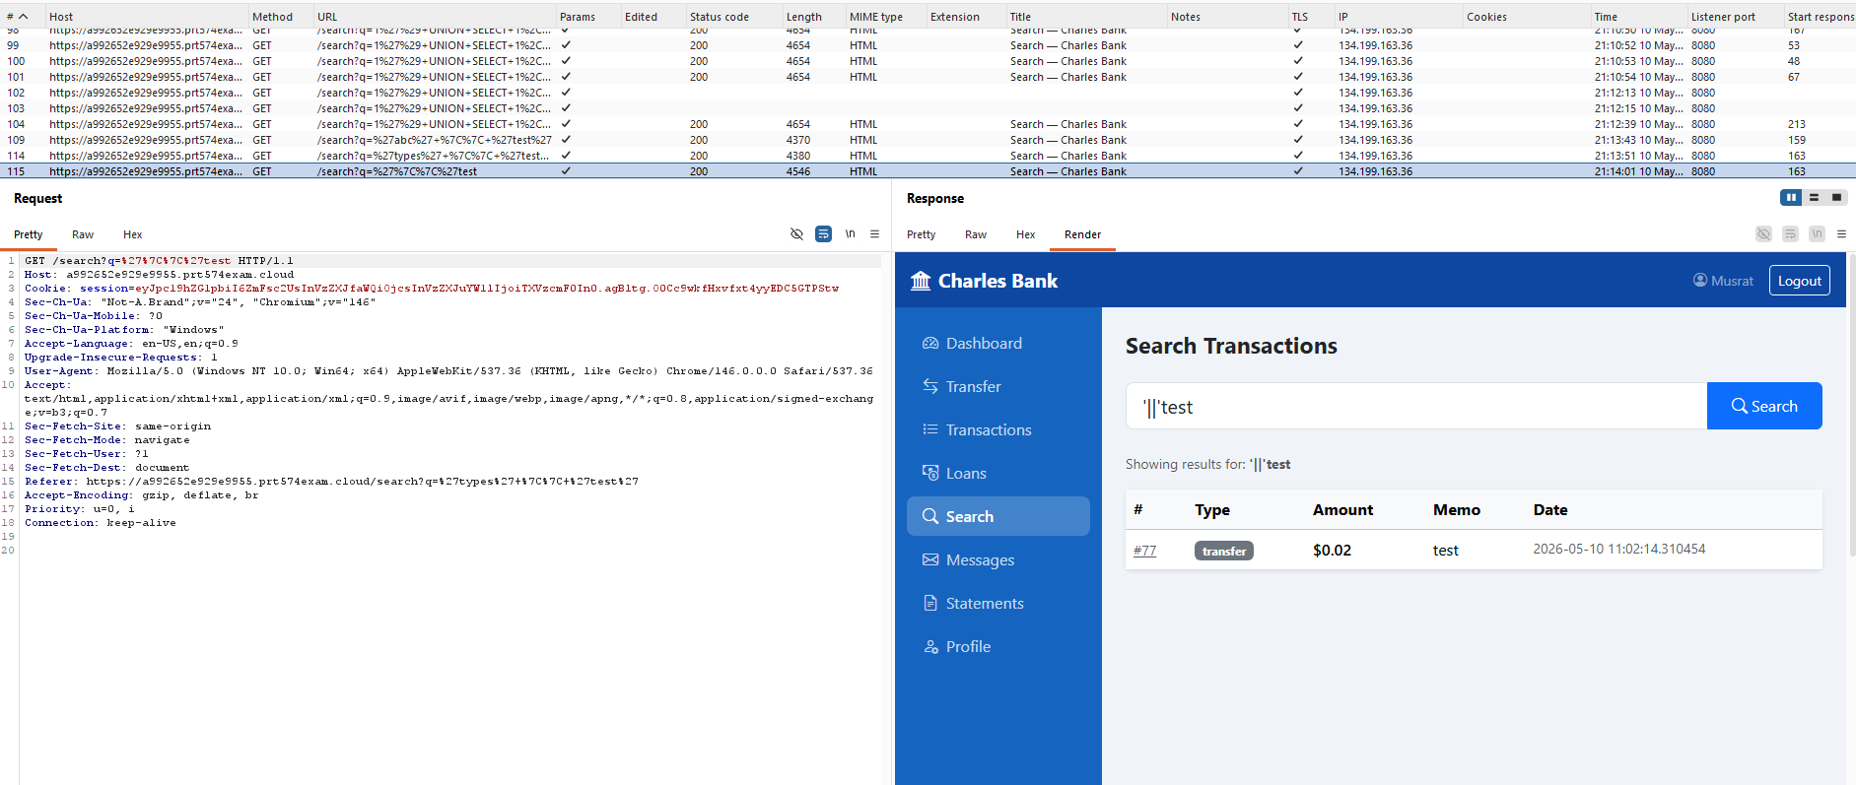

Actions taken
- Entered the payload in transaction search functionality: '||'test
- Submitted the search request
- Observed that transaction records were returned with manipulated values
- Confirmed that the payload interacted directly with backend SQL processing
References: SQL Injection

4. SQL Injection Database Error Disclosure in Transaction Search

Risk: Critical | Likelihood: Very Likely | Consequence: Major
Description
The Charles Bank transaction search is vulnerable to SQL Injection because user input is directly included in SQL queries without proper validation. Testing showed that SQL payloads triggered SQLite errors and exposed backend query details, including table and column names such as the transactions table, id, from_account, to_account, amount, memo, transaction_type, timestamp. This confirms insecure input handling and poor database protection.
Impact
An attacker can:
- Access sensitive banking data
- Discover database structure
- Bypass search restrictions
- Manipulate SQL queries
- Potentially compromise the database
This may result in unauthorized access, data exposure, and financial fraud.
Evidence
Evidence 1:’UNION SELECT 1,2,3,name FROM sqlite_master WHERE type='table'—

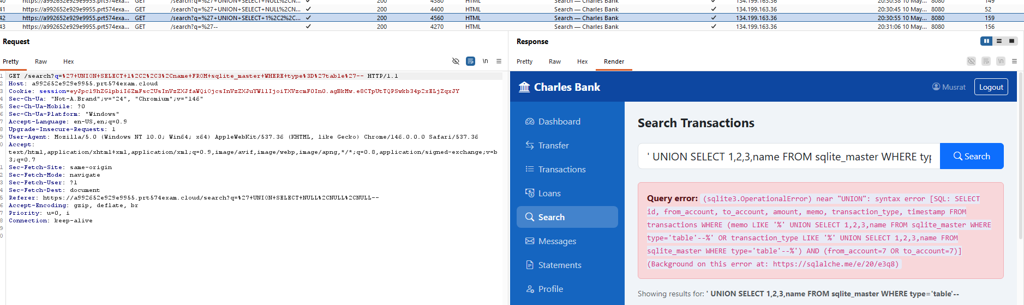

Evidence 2:' UNION SELECT NULL—

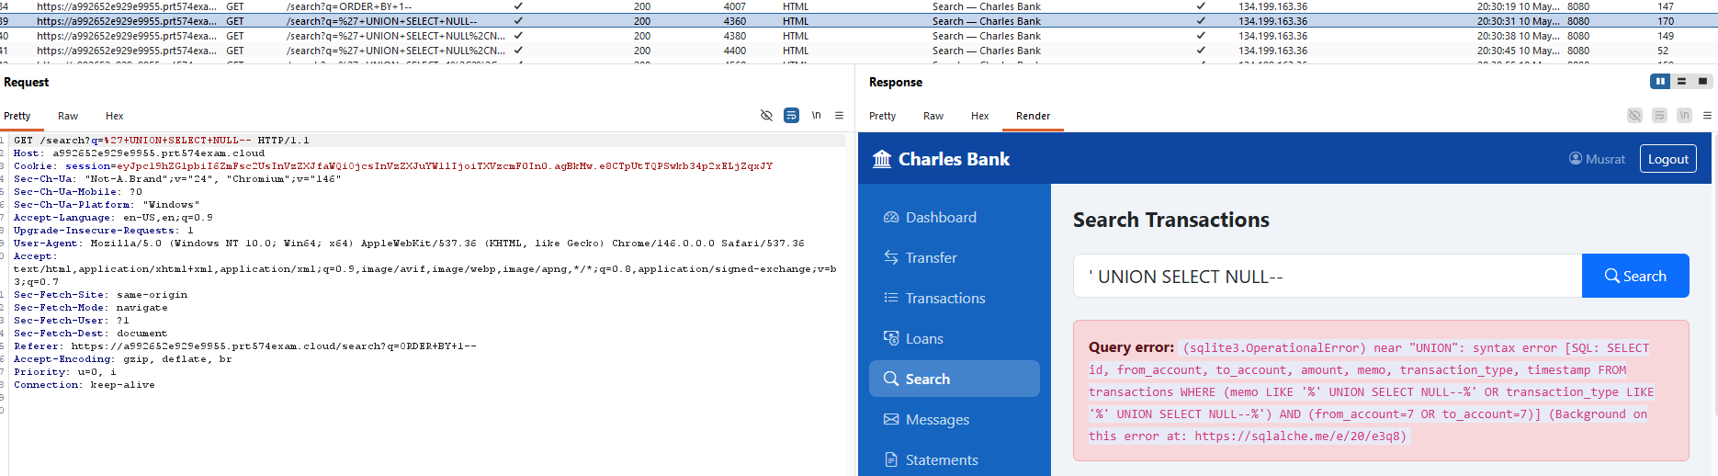

Evidence 3: ' UNION SELECT NULL,NULL—

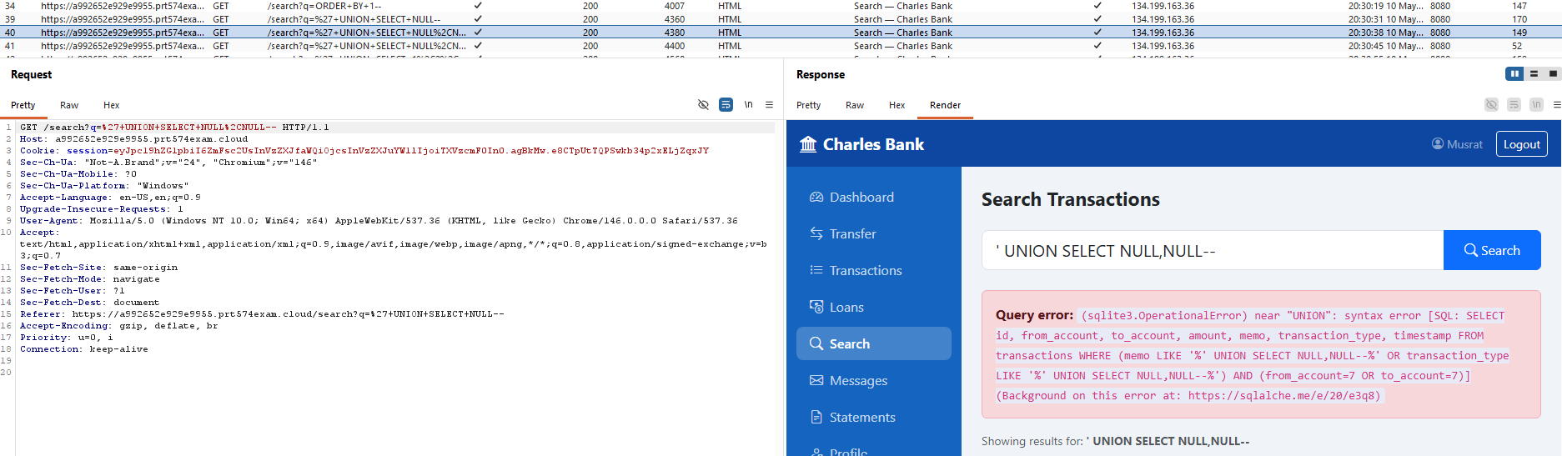

Evidence 4: ' UNION SELECT NULL,NULL, NULL—

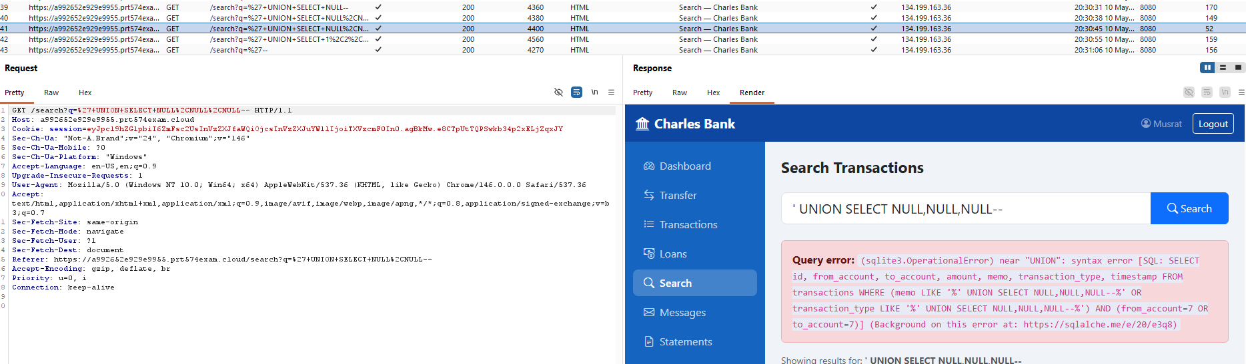

Evidence 5: ' - -

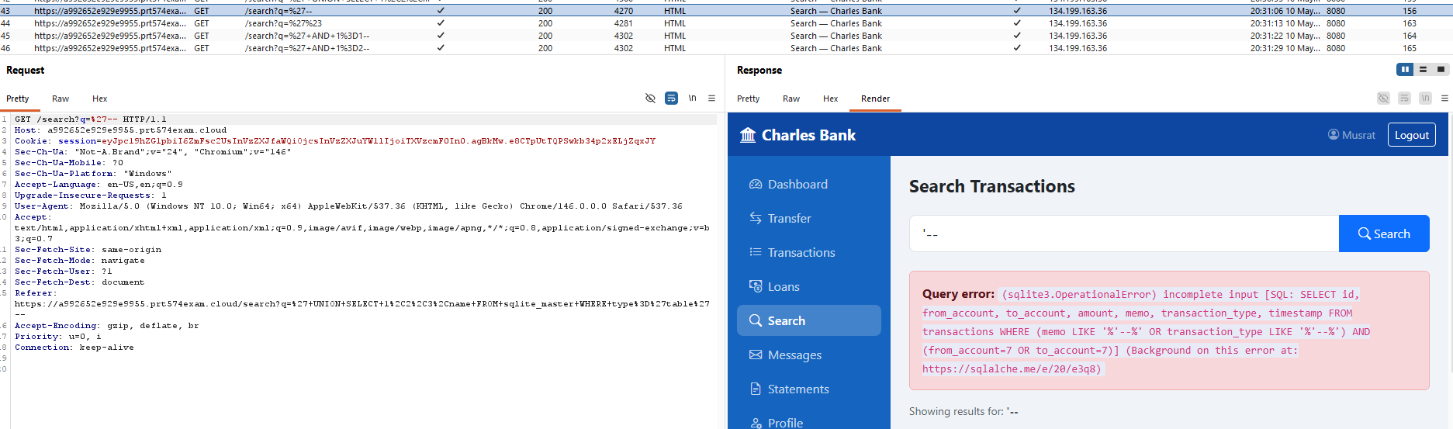
Evidence 6: ' OR 1=1--
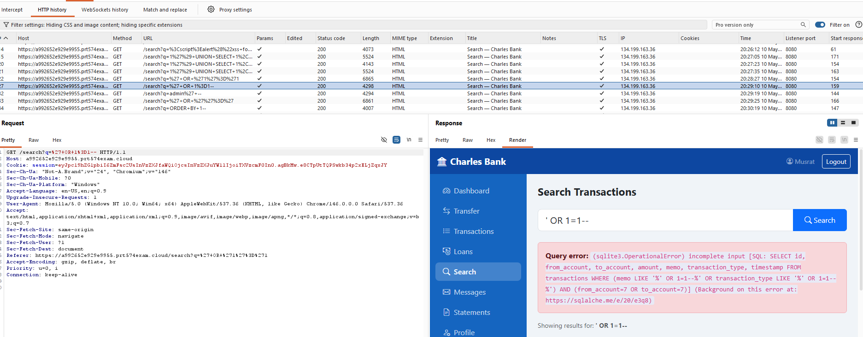

Evidence 7: '#

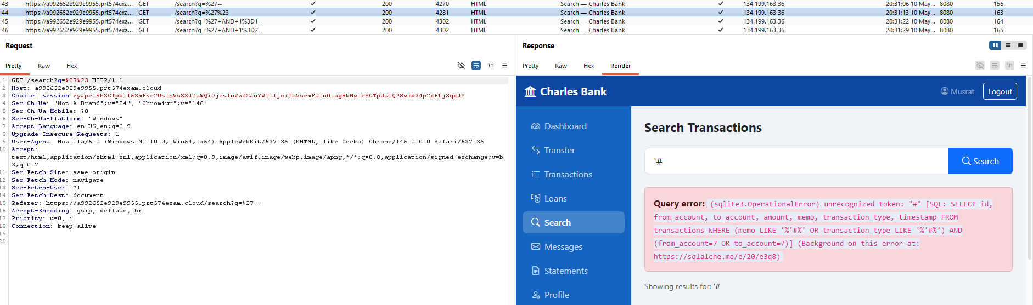

Evidence 8: 'AND 1=1--

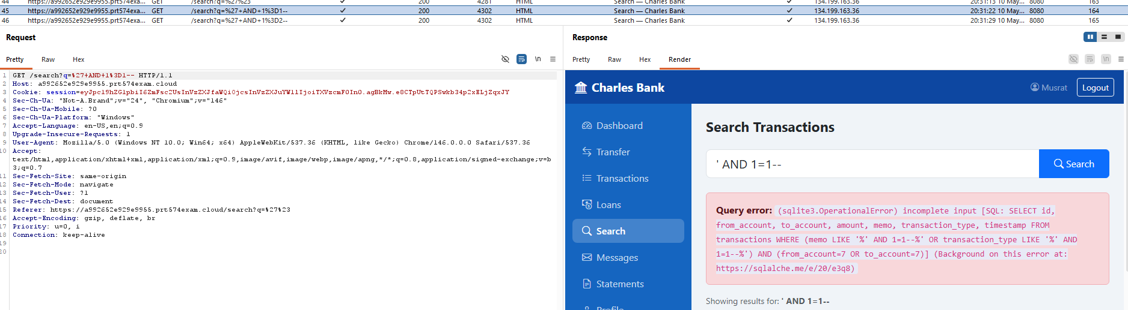

Evidence 9: 'AND 1=2--

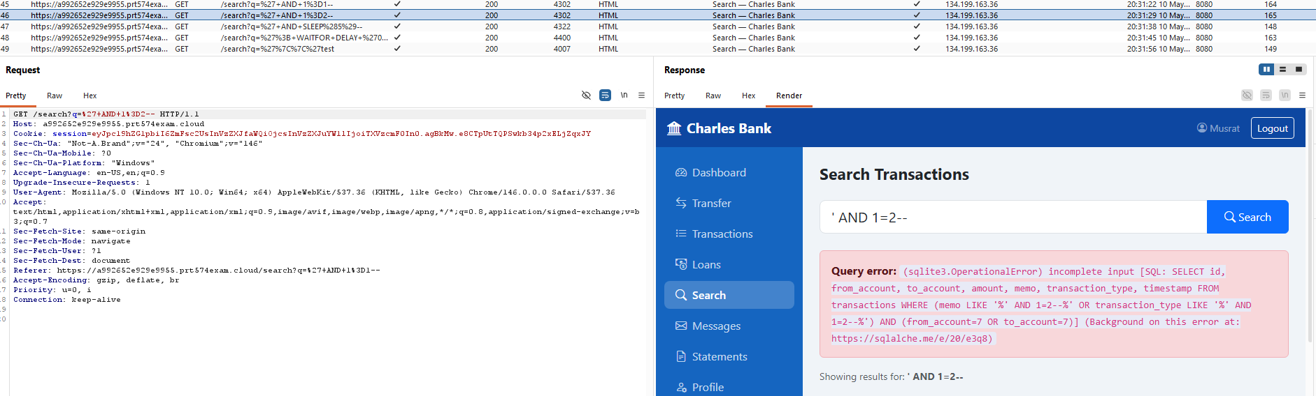

Evidence 10: 'AND SLEEP(5)--

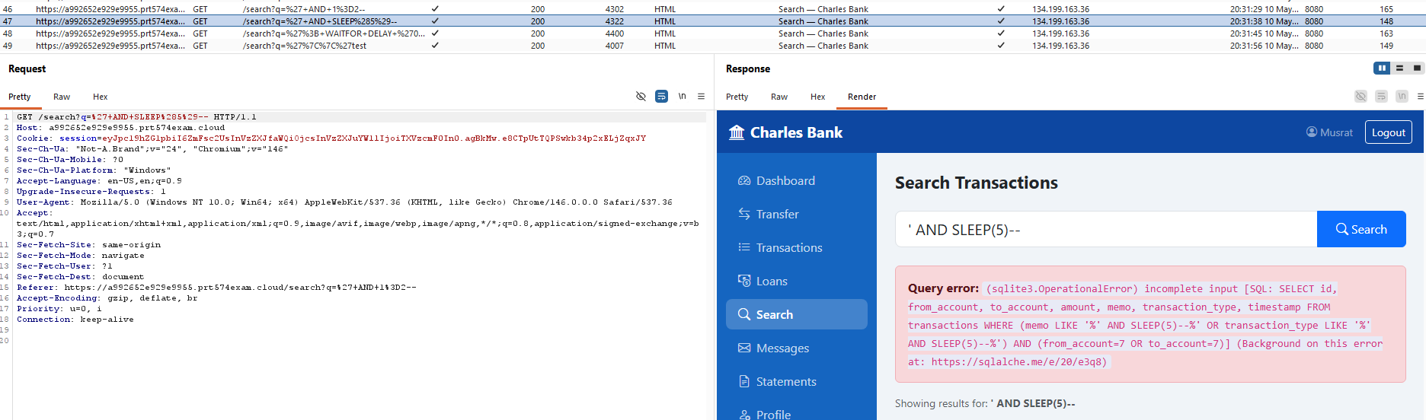

Evidence 11: ',WAITFOR DELAY '0.05'--

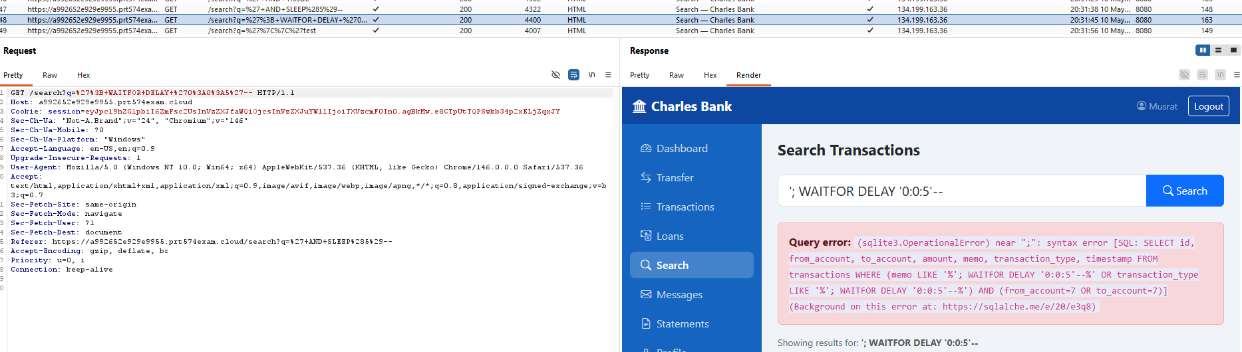

Evidence 12: admin'--
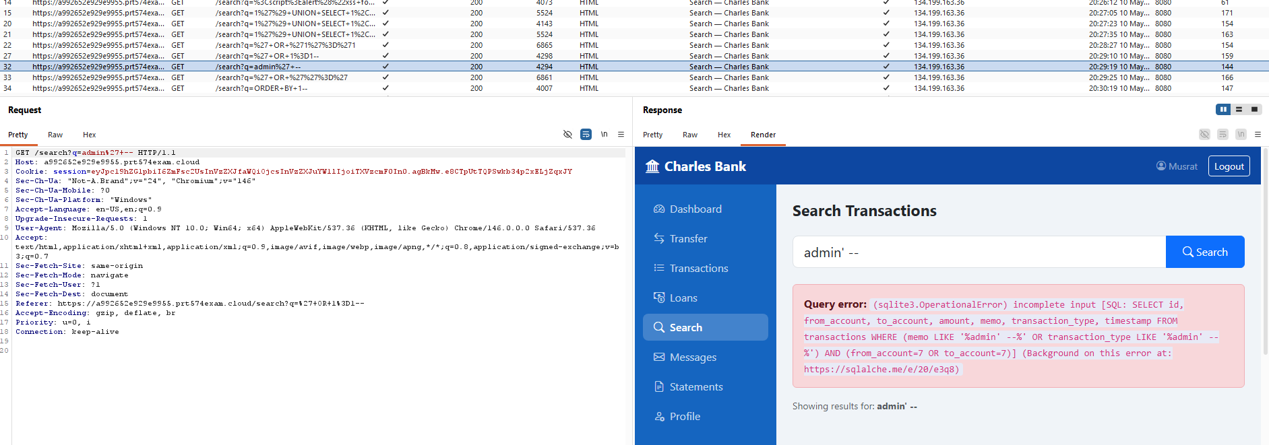
Actions taken
- Opened the transaction search page
- Entered multiple SQL Injection payloads
- Observed raw SQLite errors and exposed SQL queries
References: Error-based SQL Injection & Information Disclosure

5. SQL Injection and Database Error Disclosure in Login
Risk: Critical | Likelihood: Very Likely | Consequence: Major
Description
The Charles Bank website is vulnerable to SQL Injection because user input in the login and transaction search fields is not properly validated. During testing, SQL payloads such as:
administrator'--, admin--,admin’--,admin,’--
caused the system to return raw SQLite database errors and expose backend SQL queries, table names, column names, and password hash information.
This confirms that user input is directly inserted into SQL queries without proper security controls.
Impact
An attacker could:
- Bypass login authentication
- Access sensitive banking data
- Discover database structure
- Access password hashes
- Manipulate database queries
- Potentially compromise the database
This may lead to account takeover, data exposure, and financial fraud.
Evidence

Evidence 1: administrator’--
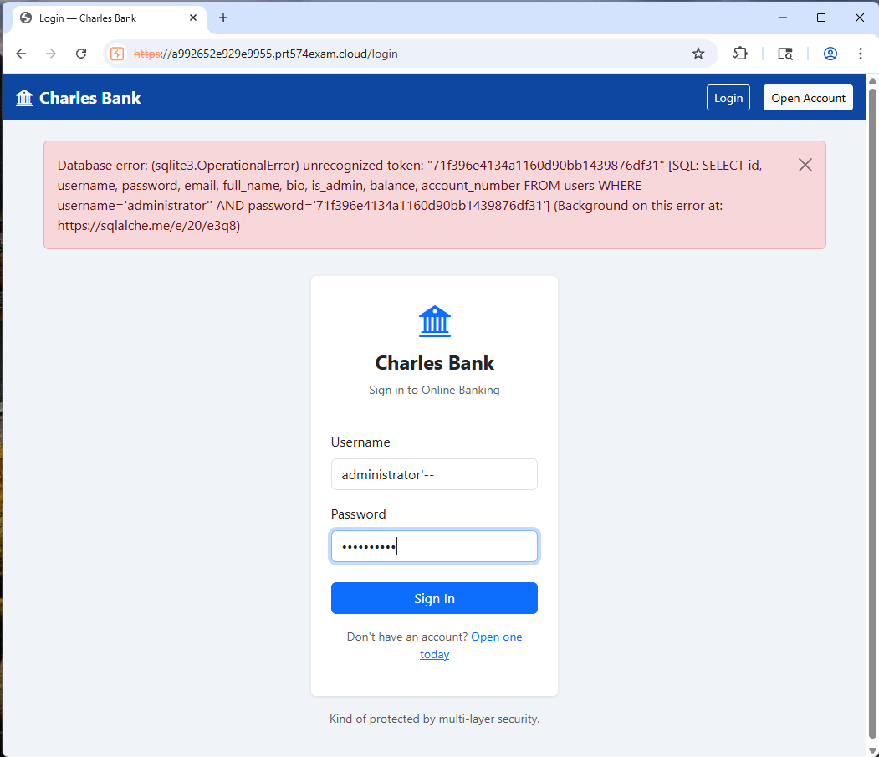

Evidence 2: admin

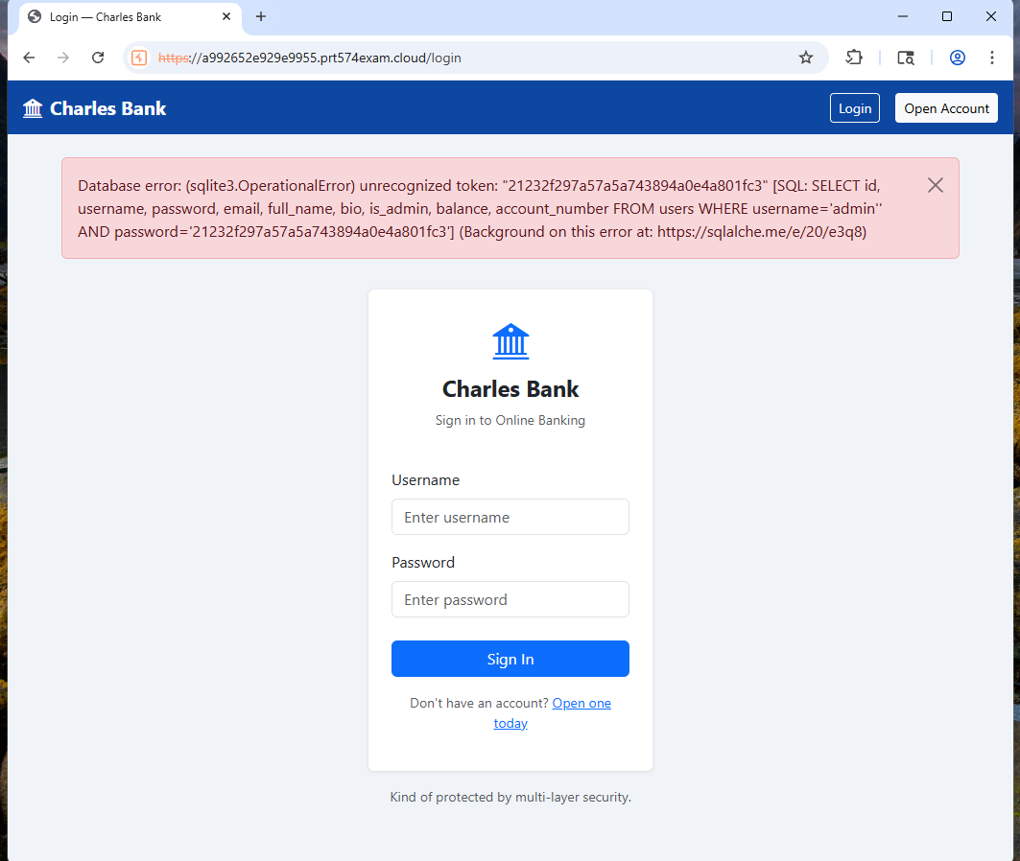

Evidence 3: ‘’

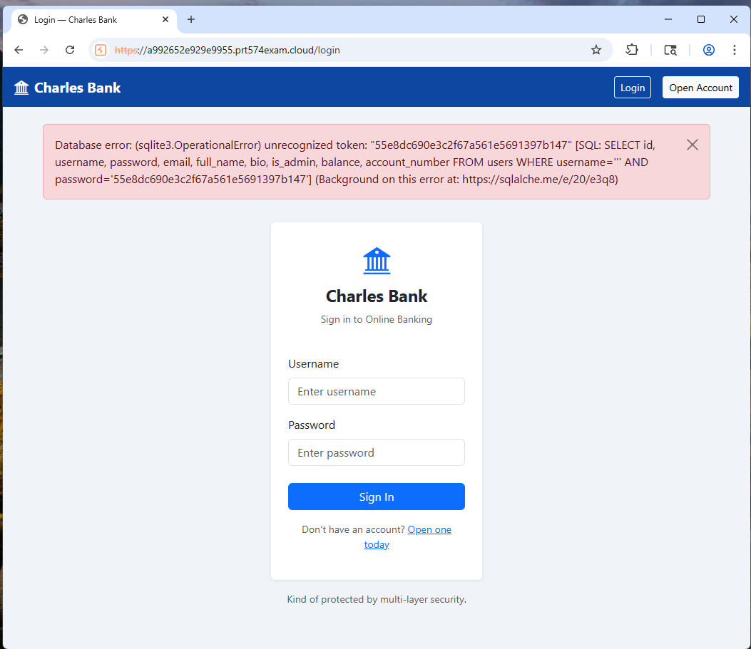

Actions taken
- administrator'-- into the username field.
- Entered SQL Injection payloads into login and search fields
- Submitted the requests
- Observed raw SQLite errors and exposed SQL queries
- Confirmed exposure of database structure information
References: Authentication Bypass SQL Injection

6. Stored Cross-Site Scripting (XSS) in message

Risk: Critical | Likelihood: Very Likely | Consequence: Major
Description:
The Charles Bank messaging functionality is vulnerable to Stored Cross-Site Scripting (Stored XSS) because message content is not properly sanitised. During testing, the following payloads were inserted into the message body:
- <script>alert(1)</script>
- <img src=x onerror=alert(1)>
After sending and opening the message, the system automatically executed the JavaScript payload and displayed a browser pop-up message.
This confirms that malicious scripts are stored in the website and executed whenever the message is viewed.
Impact
An attacker could:
- Execute malicious JavaScript in victim browsers
- Steal session cookies and tokens
- Hijack authenticated banking sessions
- Access sensitive banking information
- Perform phishing or malicious actions
In the Charles Bank system, this could lead to account compromise and financial fraud.

Evidence
Evidence 1:<script>alert(1)</script>
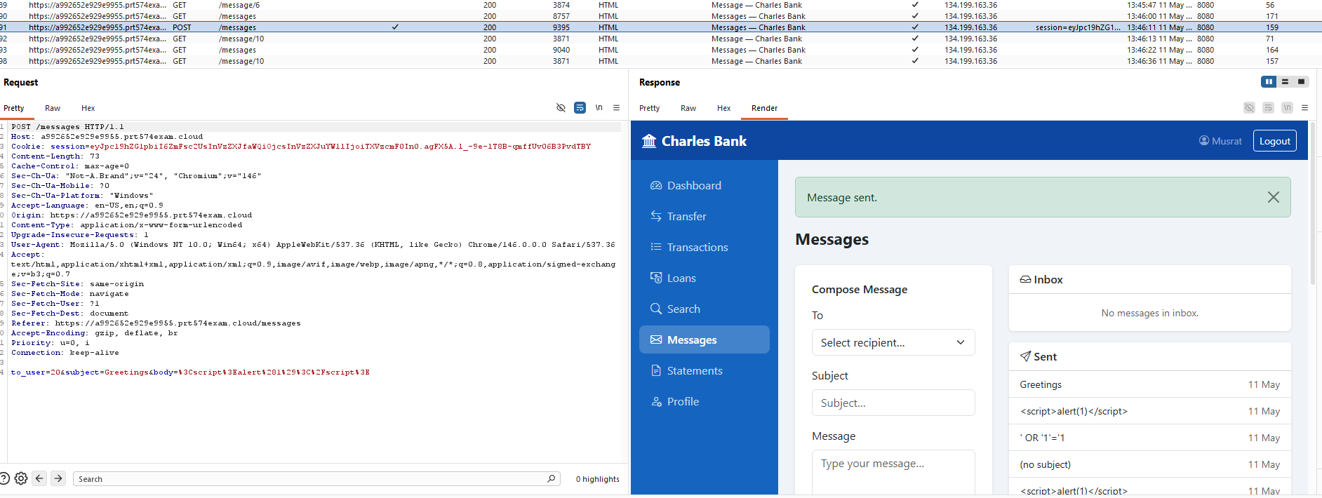

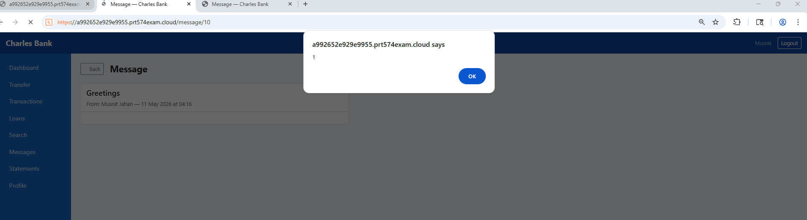

Evidence 2:<<img src=x onerror=alert(1)>

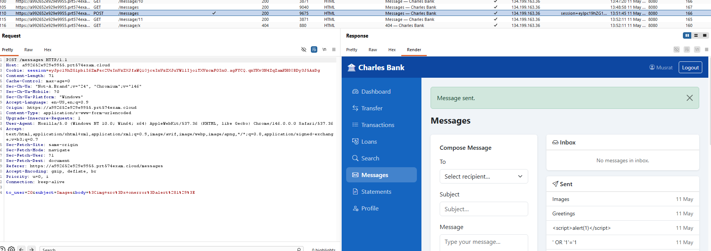

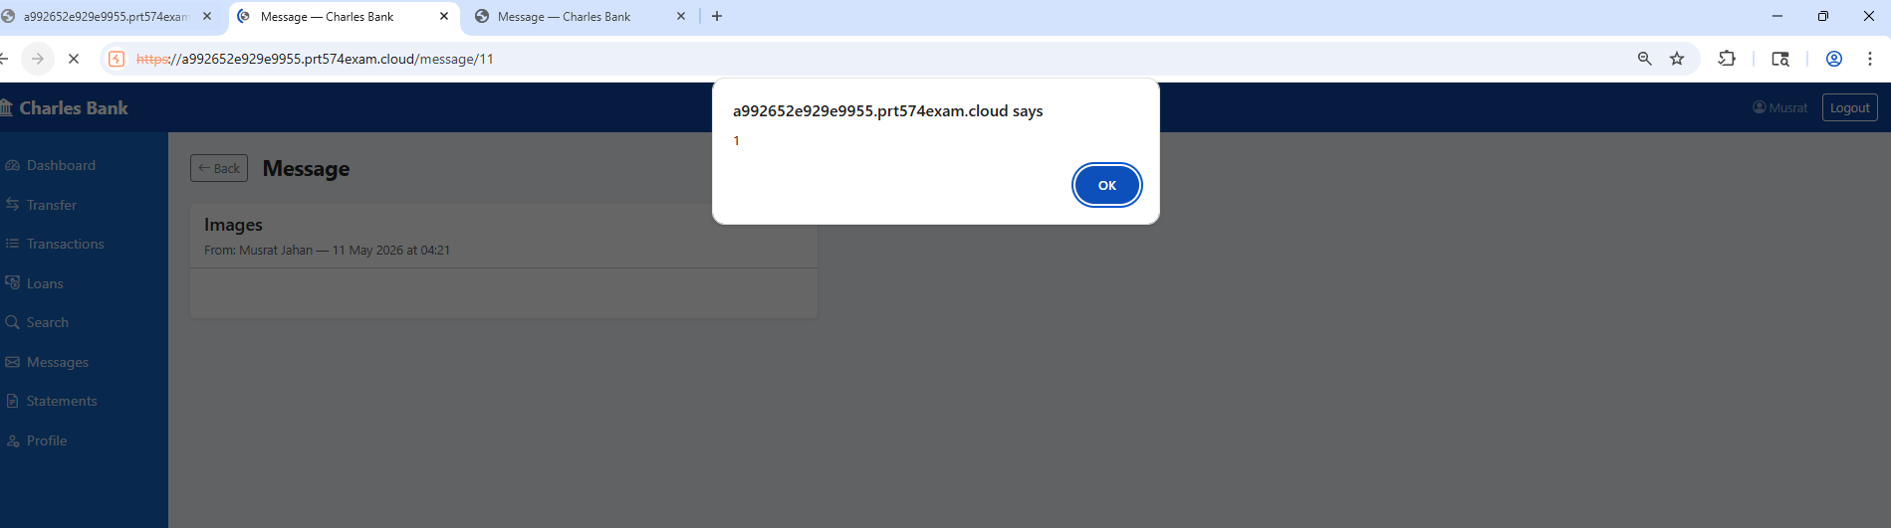

Actions taken
- Opened the messaging functionality
- Sent messages containing XSS payloads
- Opened the received message
- Observed automatic JavaScript execution and browser pop-up alerts
References: Stored Cross-Site Scripting (Stored XSS)

07. Reflected Cross-Site Scripting (XSS) in Transaction Search
Risk: Critical | Likelihood: Very Likely | Consequence: Major
Description
he Charles Bank transaction search is vulnerable to Reflected Cross-Site Scripting (XSS) because user input is not properly sanitised. During testing, the following payload was entered into the search field:
- <script>alert(1)</script>
- <img src=x onerror=alert(1)>
- <body onload=alert(1)>
After submitting the payload, the system executed the JavaScript and displayed a browser pop-up message: a992652e929e9955.prt574exam.cloud says 1
This confirms that the website reflects unsanitised user input directly into the webpage and treats it as executable JavaScript

Impact
An attacker could:
- Execute malicious JavaScript in victim browsers
- Steal session cookies and authentication tokens
- Hijack authenticated user sessions
- Access sensitive banking information
- Redirect users to malicious websites
In the Charles Bank system, this could lead to account compromise, customer data theft, and financial fraud.
Evidence
Evidence 1: <script>alert(1)</script>

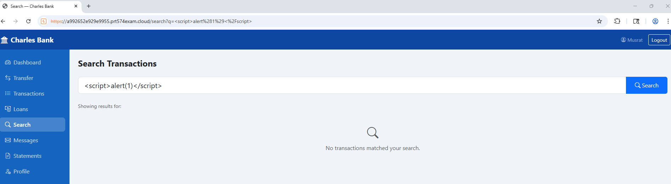
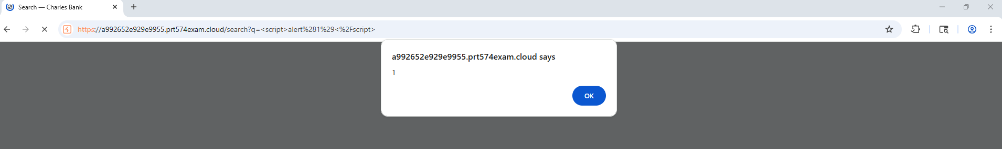

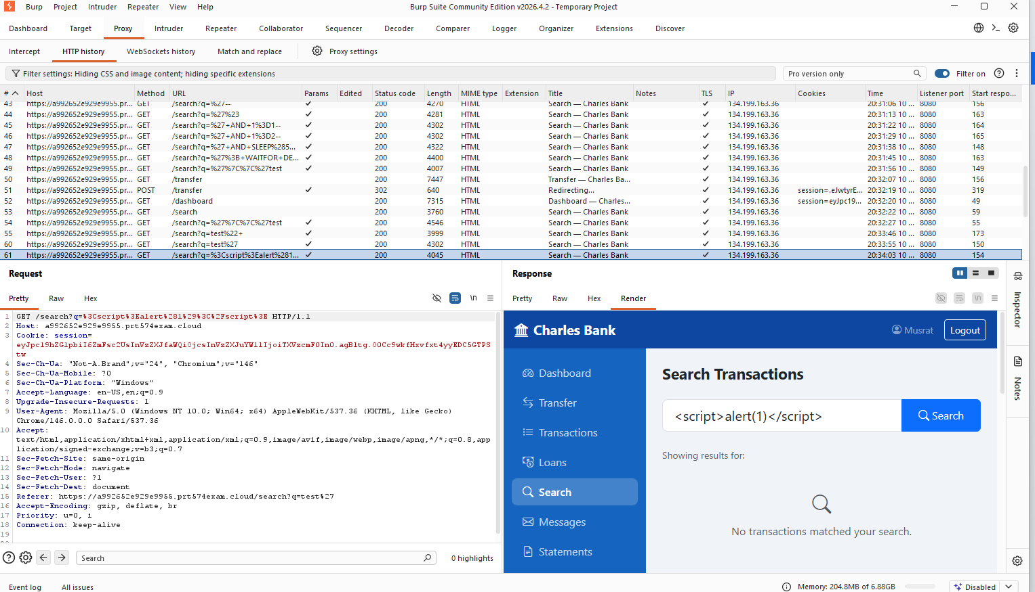

Evidence 2: <img src=x onerror=alert(1)>

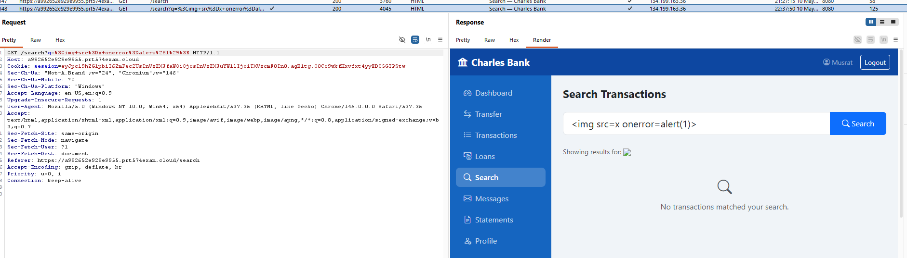

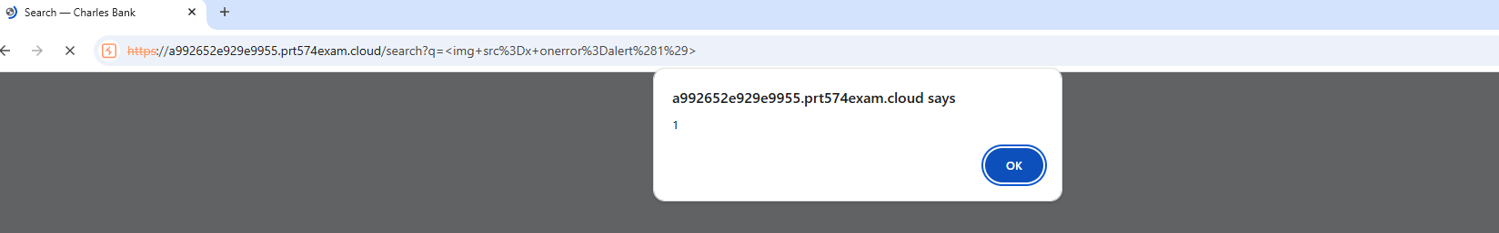

Evidence 3: <body onload=alert(1)>

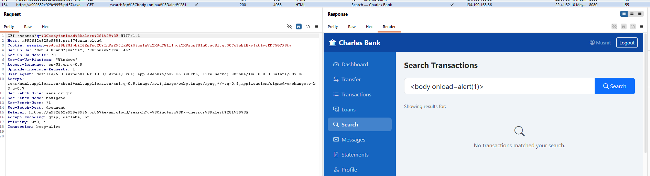

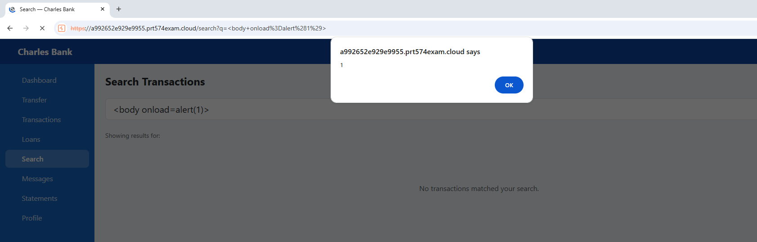

Actions taken
- Opened the Transaction search functionality
- Sent XSS payloads:
  - <script>alert(1)</script>
  - <img src=x onerror=alert(1)>
  - <body onload=alert(1)>
- Observed automatic JavaScript execution and browser pop-up alerts
References: Reflected Cross-Site Scripting (XSS)

8. Cross-Site Scripting (XSS) in Transaction Search

Risk: Critical | Likelihood: Very Likely | Consequence: Major
Description
The Charles Bank transaction search functionality is vulnerable to Reflected Cross-Site Scripting (XSS) because user input is not properly sanitised. During testing, the following payload was entered into the search field:
- <script>alert("xss found")</script>
After submitting the payload, the system executed the JavaScript and displayed a browser pop-up alert.
This confirms that the website reflects unsensitised user input directly into the webpage without proper filtering or output encoding.

Impact
An attacker could:
- Execute malicious JavaScript in victim browsers
- Steal session cookies and authentication tokens
- Hijack authenticated user sessions
- Access sensitive banking information
- Redirect users to malicious websites
In the Charles Bank system, this could lead to account compromise, customer data theft, and financial fraud.
Evidence

Evidence 1: <script>alert("xss found")</script>

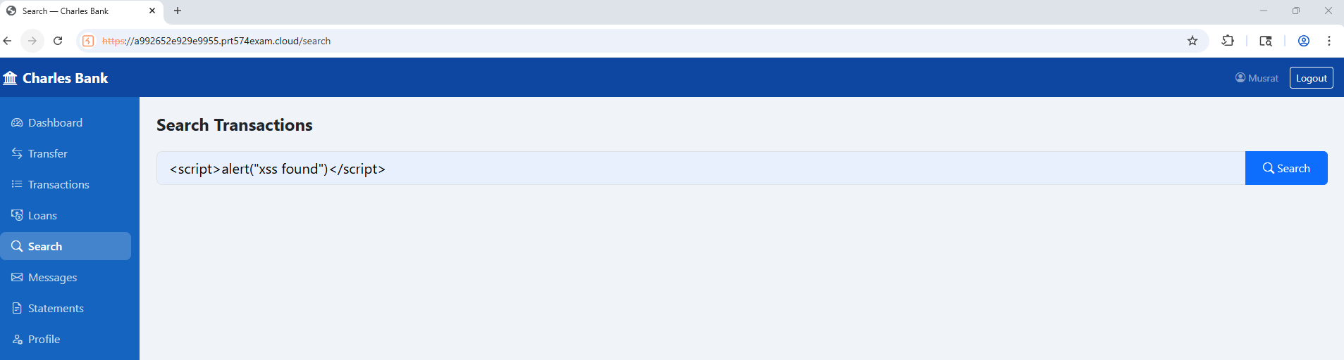

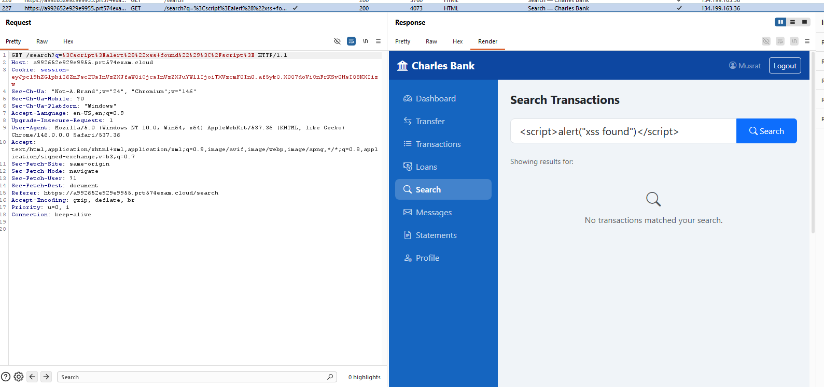

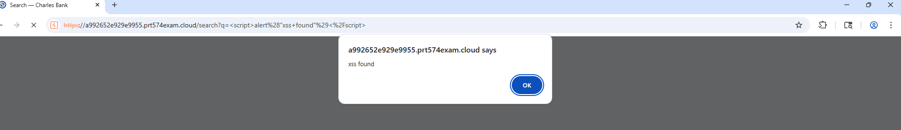

Actions taken
- Opened the transaction search functionality
- Entered the XSS payload into the search field
- Submitted the request
- Observed successful JavaScript execution and browser pop-up alert
References: Reflected or Stored XSS

09. Race Condition in Fund Transfer

Risk: Critical | Likelihood: Very Likely | Consequence: Major
Description
The Charles Bank fund transfer functionality is vulnerable to a Race Condition due to improper balance validation and transaction processing. During testing, the same transfer request was sent 5 times in parallel using Burp Suite with the amount:
$11000000000000.00
The website processed all requests successfully without checking whether the sender account had sufficient balance.
This confirms that the system lacks proper transaction locking, balance validation, and protection against simultaneous requests.
Impact
An attacker could:
- Transfer funds beyond the available balance
- Create unauthorized negative balances
- Duplicate transactions
- Manipulate financial records
In the Charles Bank system, this could lead to financial fraud, incorrect balances, and accounting errors.
Evidence
Evidence 1: 5 times same fund transfer
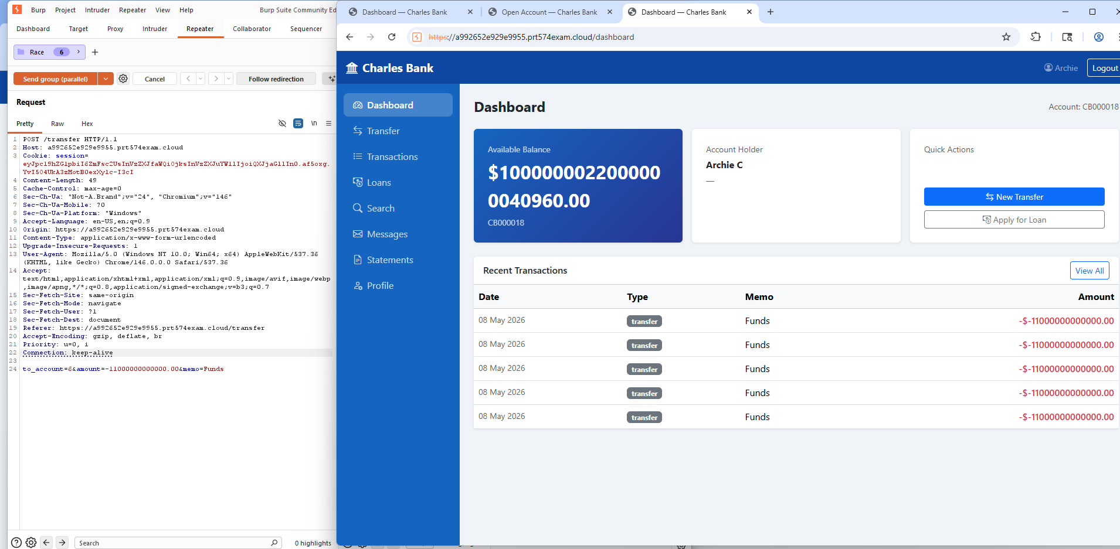

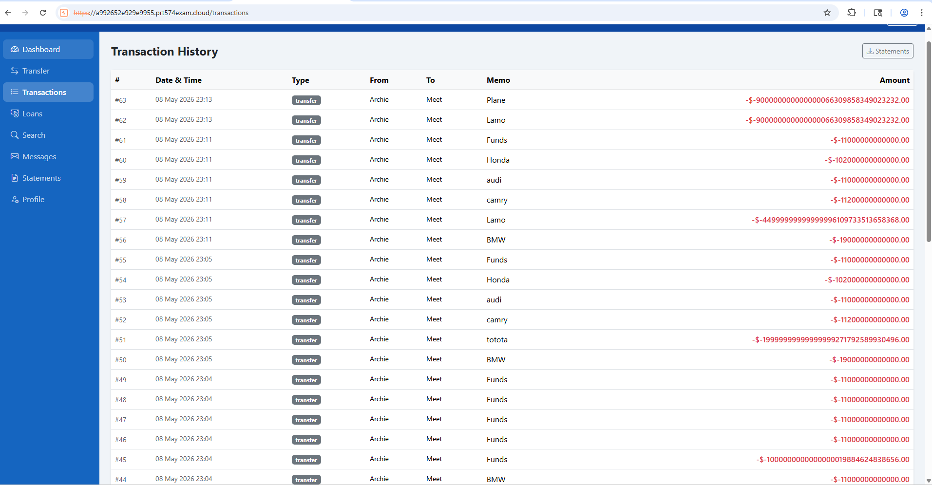
Actions taken
- Accessed the fund transfer functionality in the Charles Bank website
- Intercepted the transfer request using Burp Suite
- Replayed the same transfer request five times in parallel
- Used the transfer amount: $11,000,000,000,000.00
- Observed that all requests were processed successfully
- Verified that the account balance was not properly checked or locked during concurrent requests
References: Race Conditions

10. Authentication (Weak Password Policy During Account Registration)
Risk: Critical | Likelihood: Very Likely | Consequence: Major
Description
The Charles Bank website does not enforce strong password requirements during account registration. During testing, weak passwords such as single characters, repeated characters, digits, and special-character-only passwords were accepted successfully.
Examples accepted by the website:
- 1
- a
- ********************
- &&&&&&&&&&&&&&&&
- ssssssssssssssssssssssssssss
This confirms that the website lacks proper password complexity and validation controls.
Impact
An attacker could:
- Guess passwords easily
- Perform brute-force or password spraying attacks
- Gain unauthorized access to user accounts
In the Charles Bank system, weak password controls may lead to account takeover, financial fraud, and unauthorized access to customer information. This risk is increased because the website also contains authentication flaws.
Evidence
Evidence 1: Special character-only password: ********************
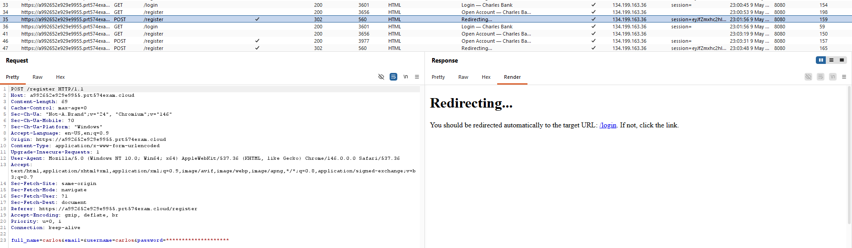
Evidence 2 : Single digit password: 1

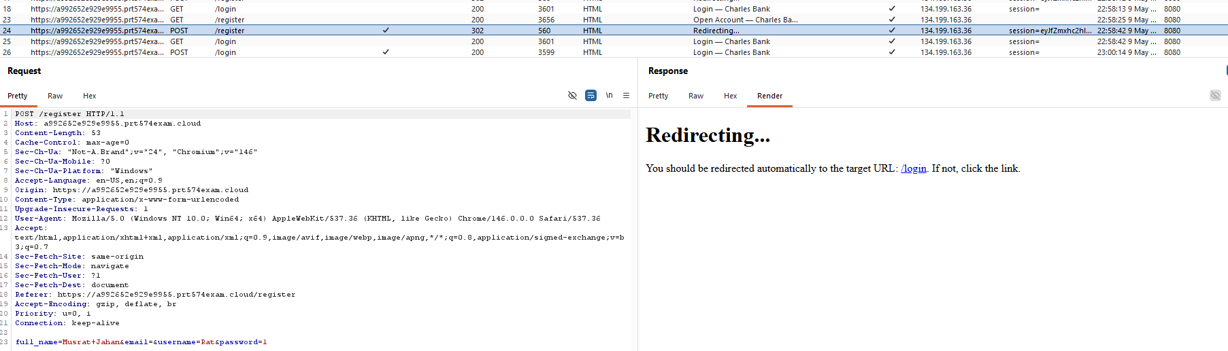

Evidence 3 : Special character-only password: &&&&&&&&&&&&&&&&
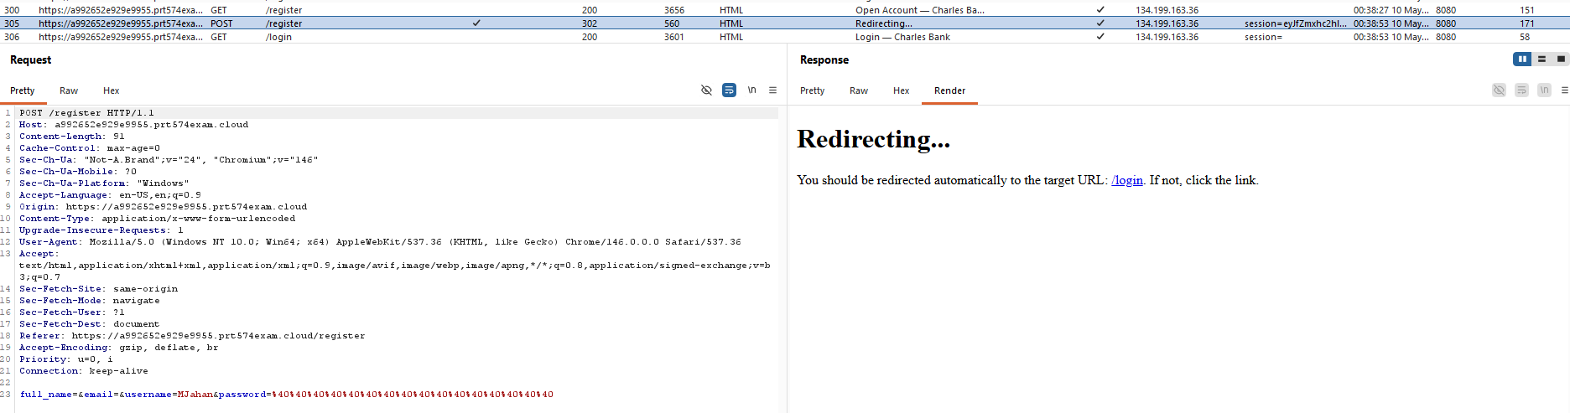

Evidence 4 : Single letter password: a

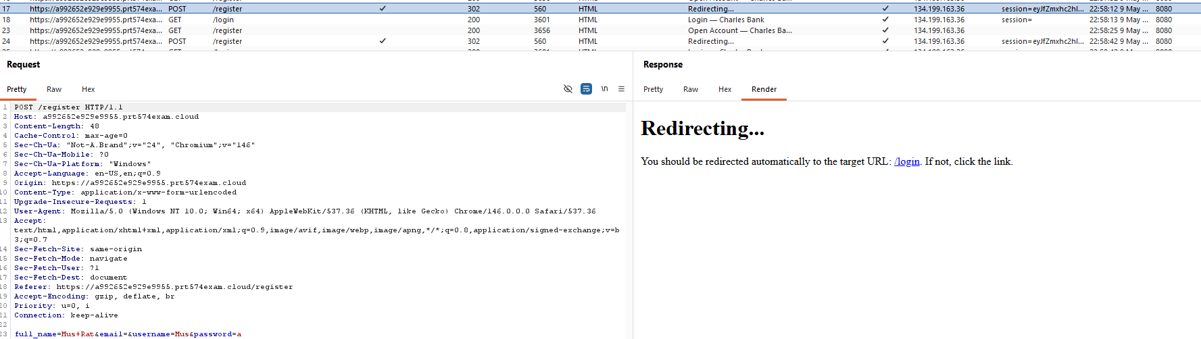

Evidence 4 : Long password: ssssssssssssssssssssssssssssssssssssssssssssssssssssssssssssssssssssssssss

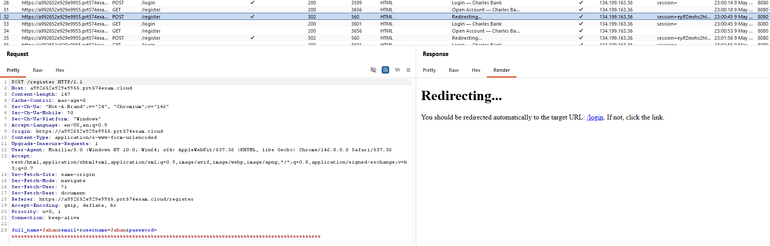

Actions taken
- Opened the Charles Bank registration page
- Tested multiple weak password values & submitted the registration form
- Confirmed that all weak passwords were accepted
References: Weak Password Requirements & Identification and Authentication Failures

11. Authentication (Improper Username Input Validation During Registration)

Risk: High | Likelihood: Very Likely | Consequence: Major
Description
The Charles Bank registration functionality does not properly validate username input. During testing, the website accepted usernames containing long text, only digits, and special characters without any validation errors.
Examples accepted by the website:
- musratjahancharlesdarwinuniversitysecurityassessment
- 1
- &&&&&&
- --
This confirms that the website lacks proper username validation and format restrictions.
Impact
An attacker could:
- Create misleading or malformed accounts
- Abuse special characters for testing or attacks
- Cause account confusion or impersonation
- Exploit authentication weaknesses more easily
In the Charles Bank system, weak username validation may lead to phishing, impersonation, and security issues.
Evidence
Evidence 1: Long text username: musratjahancharlesdrawinuniversity securityassessment

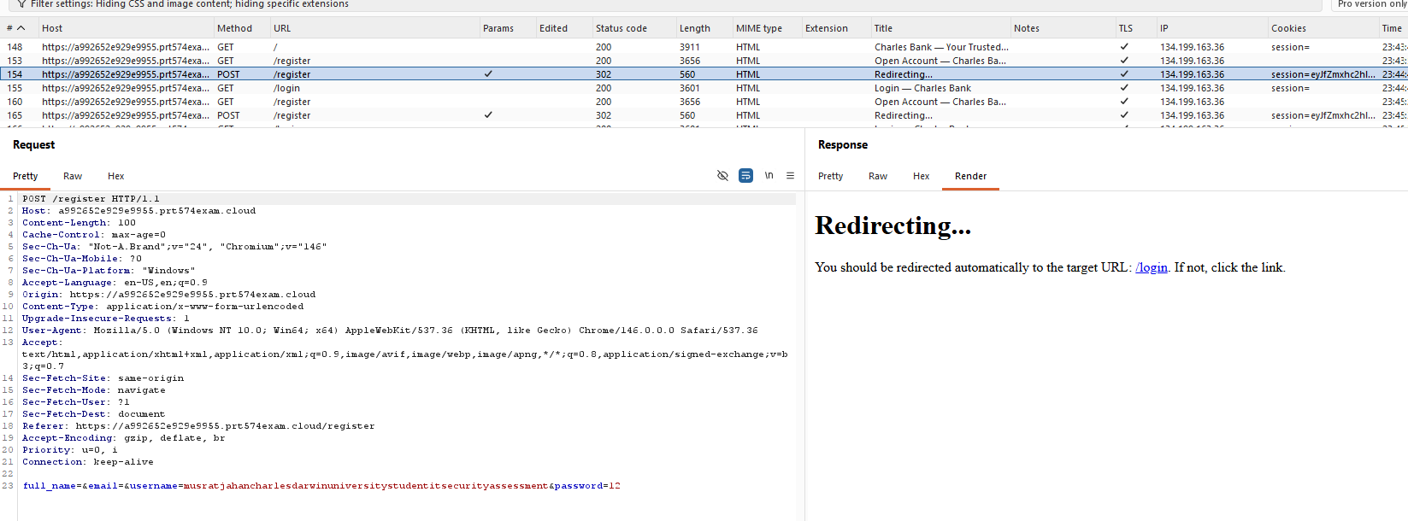

Evidence 2: Numeric username: 1

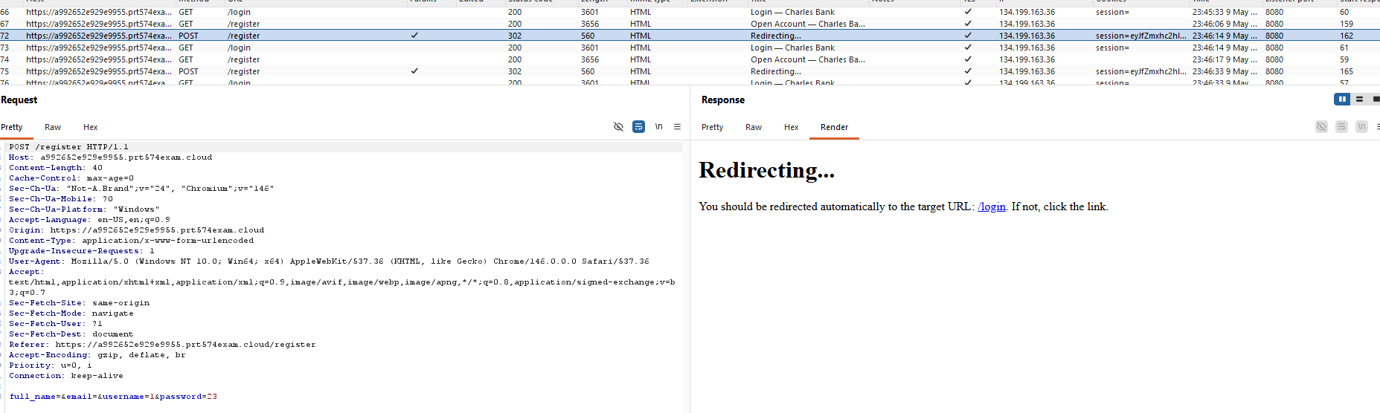

Evidence 3: Special character username: &&&&&&

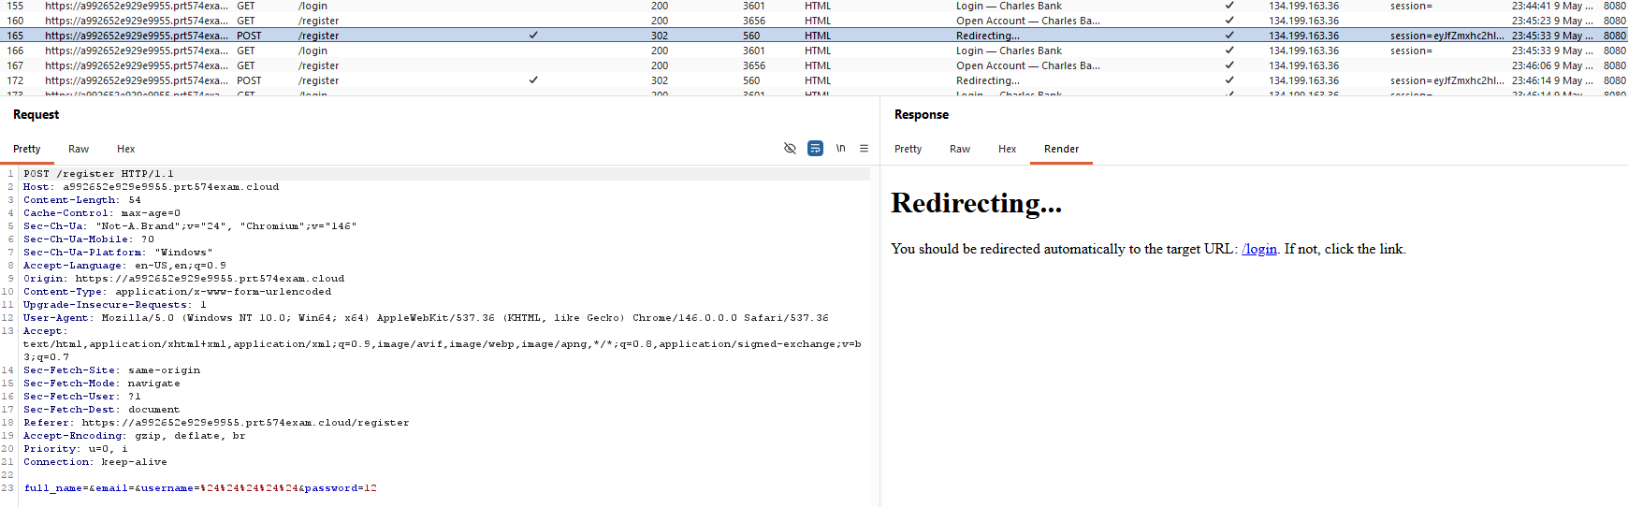

Evidence 4: Special character username: --

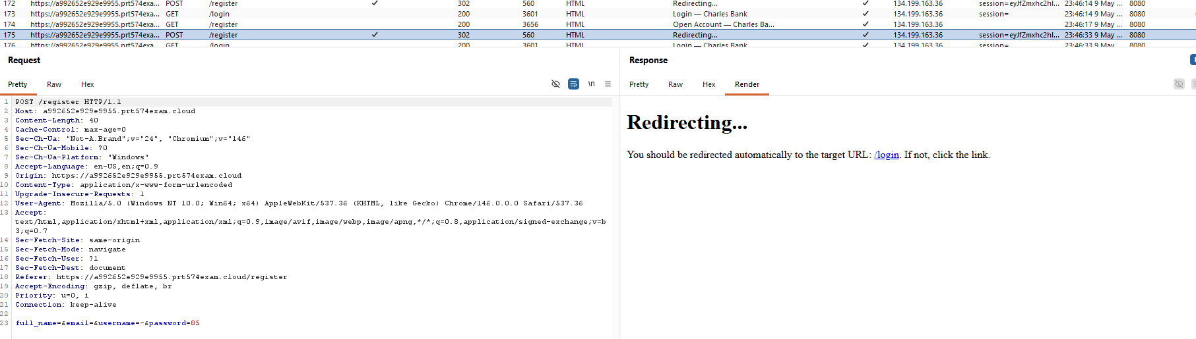

Actions taken
- Opened the Charles Bank registration page
- Entered multiple abnormal username values
- Submitted the registration form
- Confirmed that all usernames were accepted successfully
References: Identification and Authentication Failures & Weak Account Registration Controls

12. Authentication (Missing Account Lockout Protection Against Repeated Failed Login Attempts)

Risk: High | Likelihood: Very Likely | Consequence: Major
Description
The Charles Bank authentication system does not implement account lockout or brute-force protection mechanisms. During testing, more than 10 failed login attempts were performed using the valid username:
- Mus
The website displayed the error message:
- Invalid password or username
However, the account was not locked, rate limited, or protected against repeated login attempts.
This confirms that the website lacks account lockout, rate limiting, and brute-force protection controls.
Impact
An attacker could:
- Perform brute-force attacks
- Continuously guess passwords
- Gain unauthorized access to user accounts
When combined with weak password policies and authentication flaws, this increases the risk of account compromise and financial fraud.

Evidence
Evidence 1: Multiple Failed Login Attempts
Performed repeated login attempts using:
- Username: Mus
- Incorrect passwords

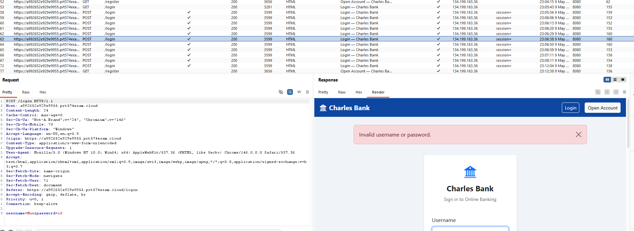

Actions taken
- Opened the Charles Bank login page
- Entered the valid username Mus
- Submitted incorrect passwords repeatedly
- Performed more than 10 failed login attempts
- Confirmed that no account lockout or rate limiting was triggered
References : Identification and Authentication Failures

13. Authentication Bypass Due to Password-Only Login Validation

Risk: Critical | Likelihood: Very Likely | Consequence: Major
Description
The Charles Bank login functionality does not correctly validate the username and password combination. During testing, the website allowed login with an incorrect username as long as the password matched an existing account.
Example:
- Correct username: Archie
- Correct password: 1234

When a random username was entered with the password 1234, the website still logged into Archie’s account.
This confirms that the system validates only the password and does not properly verify the username and password pair.

Impact
An attacker could:
- Gain unauthorized access to user accounts
- Log in without knowing the correct username
- Access sensitive banking information
- Perform unauthorized transactions
In the Charles Bank system, this could lead to account takeover, privacy breaches, and financial fraud.

Evidence
Evidence 1: username: any random or incorrect username & password: 1234

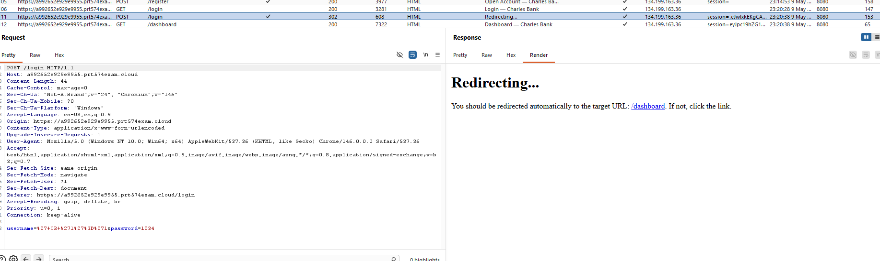

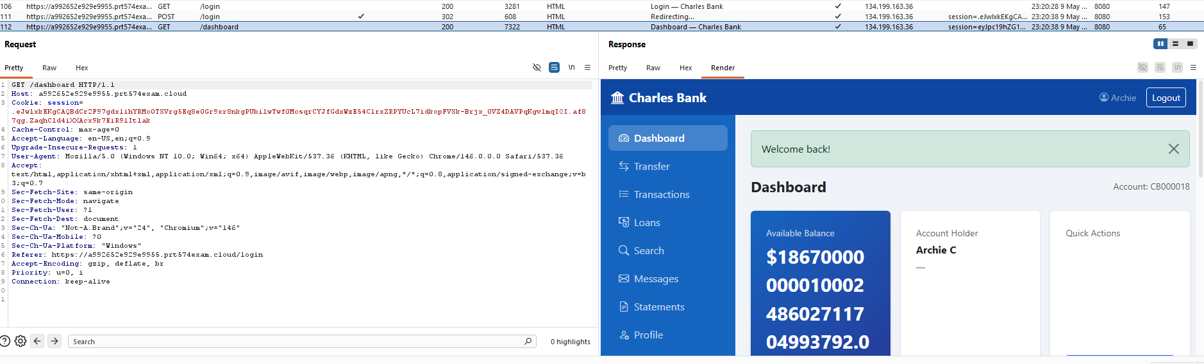

Evidence 2 : Correct username & password : Archie & 1234

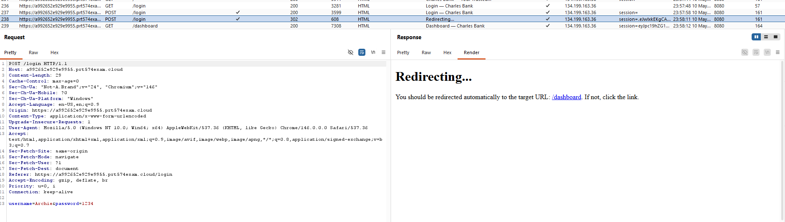

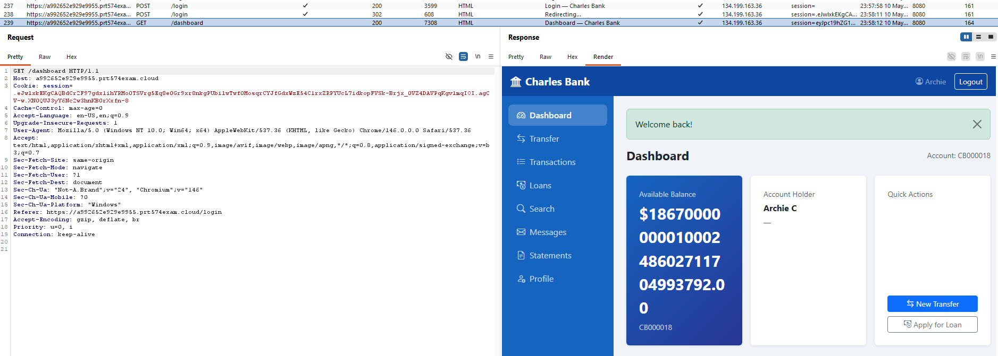

Actions taken
- Opened the Charles Bank login page
- Used the valid password 1234 with random usernames
- Submitted the login form
- Observed successful login into Archie’s account
- Repeated the test with different incorrect usernames
References: Identification and Authentication Failures

14. Authentication (Multiple Accounts Can Use the Same Weak Password)

Risk: High | Likelihood: Very Likely | Consequence: Major
Description
The Charles Bank registration functionality allows multiple users to create accounts using the same weak password. During testing, several accounts were created with different usernames but
- the same password: 1
Example usernames:
- Mustest
- test1
- test2
- test3
- test4
- Rat
All accounts were created successfully using the same weak password. This confirms that the website does not enforce strong password policies or password complexity requirements.
Impact
An attacker could:
- Guess passwords easily
- Perform brute-force or password spraying attacks
- Gain unauthorized access to user accounts
In the Charles Bank system, this could lead to account takeover, privacy breaches, and financial fraud.
Evidence
Evidence 1 : Username & password : Mustest & 1

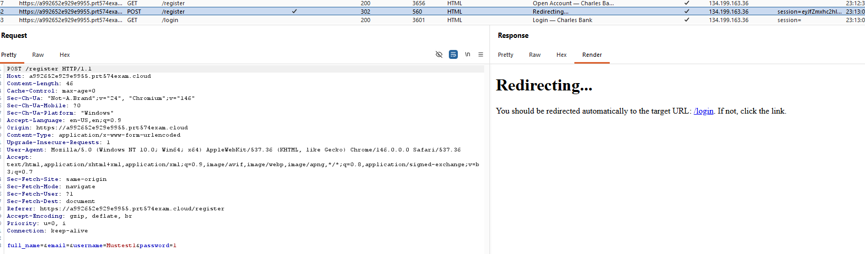

Evidence 2 : Username & password : Test2 & 1
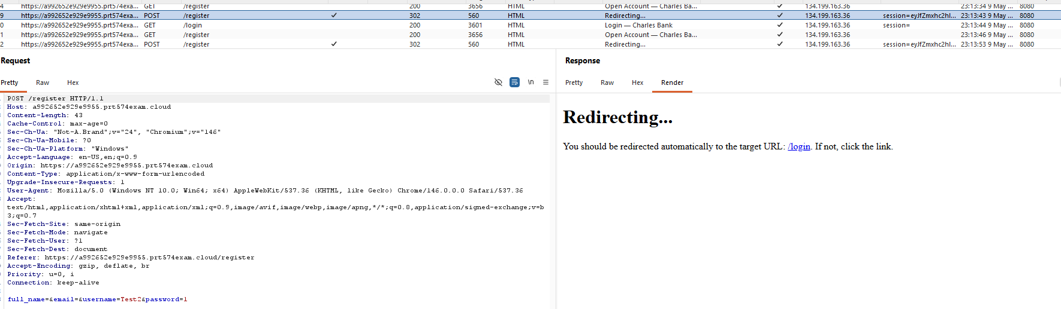

Evidence 3 : Username & password : Test3 & 1

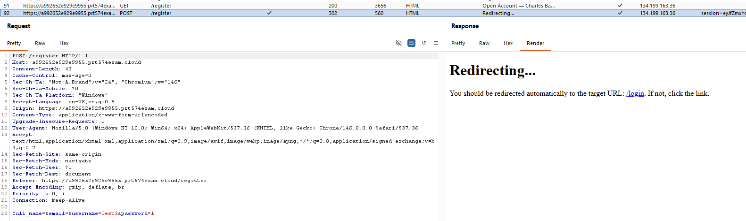

Evidence 4 : Username & password : test4 & 1

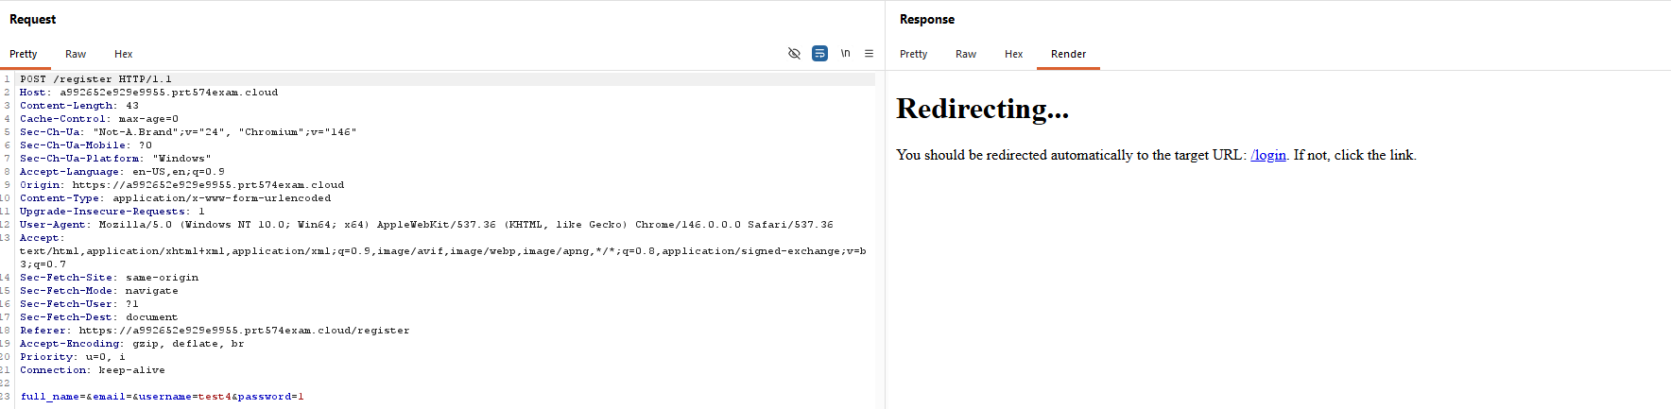

Actions taken
- Opened the Charles Bank registration page
- Created multiple accounts using different usernames
- Used the same password 1 for all accounts
- Confirmed that all accounts were created successfully
- Verified that the website accepted the reused weak password
References: Identification and Authentication Failures & Weak Password Requirements

15. Authentication Bypass Through Shared Password Matching

Risk: Critical | Likelihood: Very Likely | Consequence: Major
Description
The Charles Bank authentication system does not properly validate usernames during login. During testing, multiple accounts were created with different usernames but the same password:
- Rat
- Mustest
- test1
- test2
- test3
- test4
All accounts used the password: 1
When a random or non-existent username was entered with the password 1, the website automatically logged into the Rat account, which was the first account created with that password.
This confirms that the website ignores the username and authenticates users based only on password matching
Impact
An attacker could:
- Gain unauthorized access to accounts
- Bypass username validation
- Take over accounts using common passwords
- Access sensitive banking information and transactions
In the Charles Bank system, this could lead to account compromise, financial fraud, and customer data exposure.

Evidence
Evidence 1 : Username & password : ' or '1'='1 & 1

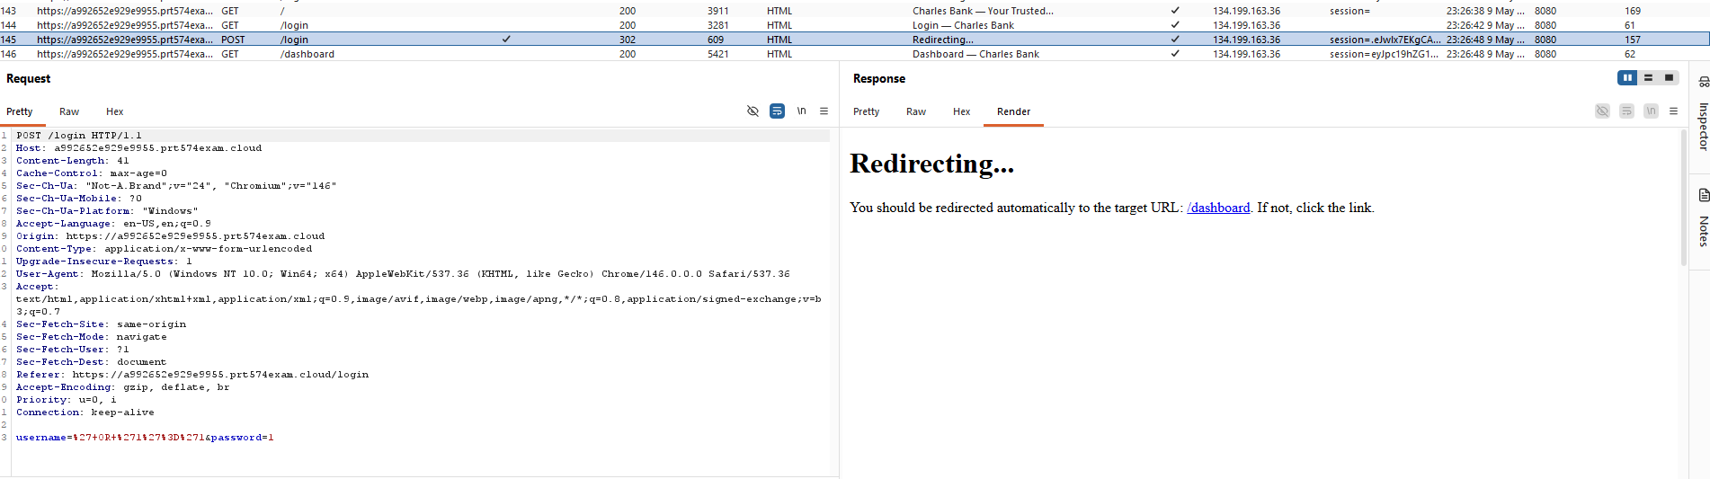
Evidence 2 : Login as Rat account. Username & password : Rat & 1

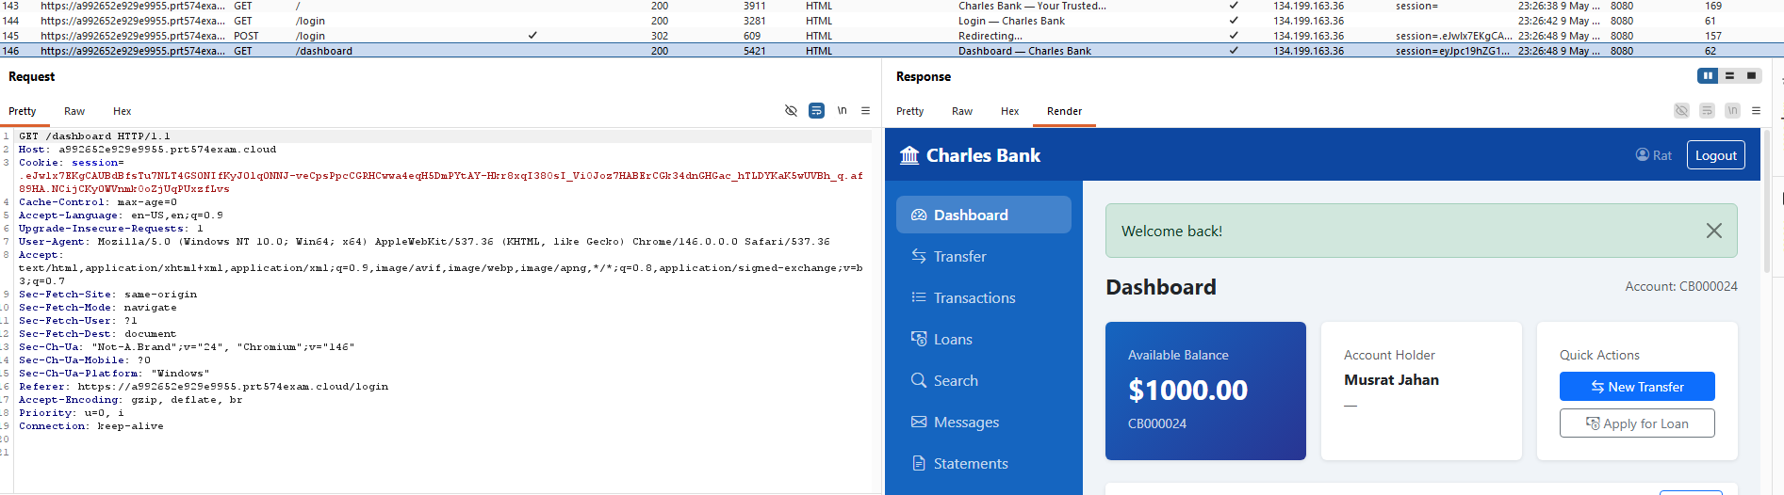
Evidence 3 : Username & password : Mustest & 1

Evidence 4 : Username & password : Test2 & 1

Evidence 5 : Username & password : Test3 & 1

Evidence 6 : Username & password : test4 & 1

Actions taken
- Created multiple accounts using different usernames and the same password
- Opened the login page
- Entered a random username with password 1
- Observed automatic login into the Rat account
- Repeated the test and confirmed the same behavior

References: Identification and Authentication Failures

16. Authorization (Unauthorized Access to Other Users’ Transactions details via URL Manipulation)

Risk: Critical | Likelihood: Very Likely | Consequence: Major
Description
The Charles Bank transaction system is vulnerable to Broken Access Control and Insecure Direct Object Reference (IDOR). During testing, authenticated users were able to access other users’ transaction records by changing the transaction ID in the URL.

The account was authorized to access:
- /transaction/16
- /transaction/17

However, changing the URL to:
- /transaction/1
- /transaction/2
- /transaction/7
allowed access to transaction details belonging to other users.
This confirms that the website does not properly verify whether the requested transaction belongs to the authenticated user.
Impact
An attacker could:
- Access other users’ transaction histories
- View sensitive financial information
- Enumerate transaction records
- Violate customer privacy
- Use exposed information for fraud or social engineering attacks
In the Charles Bank system, this could lead to serious data breaches and financial fraud.
Evidence
Evidence 1: Authorized Musrat account Transactions list.
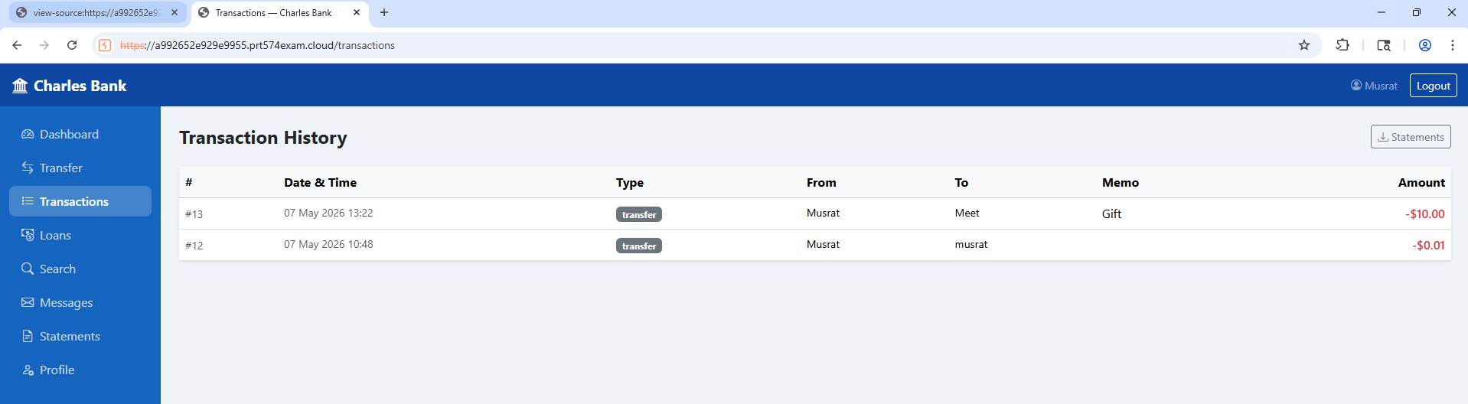

Evidence 2: Unauthorized Transactions
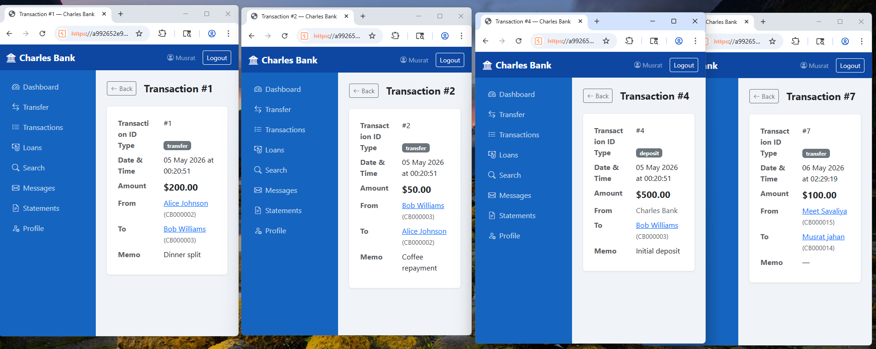

Actions taken
- Logged into the Charles Bank website using a valid account
- Opened the transaction history functionality
- Identified the transaction URL structure
- Modified transaction ID values manually in the browser URL
- Accessed unauthorized transaction records successfully
References: Broken Access Control & Authorization Bypass Through User-Controlled Key

17. Authorization (Unauthorized Access to Other Users’ Messages via URL Manipulation)

Risk: Critical | Likelihood: Very Likely | Consequence: Major
Description
The Charles Bank messaging system is vulnerable to Broken Access Control and Insecure Direct Object Reference (IDOR). During testing, users were able to access private messages belonging to other users by changing the message ID in the URL.
Although the tester’s inbox contained no messages, accessing:
- /message/2
displayed another user’s private message content.
This confirms that the website does not properly verify whether the authenticated user is authorized to access the requested message.
Impact
An attacker could:
- Read private messages belonging to other users
- Access sensitive banking communications
- Enumerate message records
- Violate customer privacy and confidentiality
- Gather information for phishing or social engineering attacks
In the Charles Bank system, this could lead to serious privacy breaches and reputational damage.

Evidence
Evidence 1: Authorized Message Access

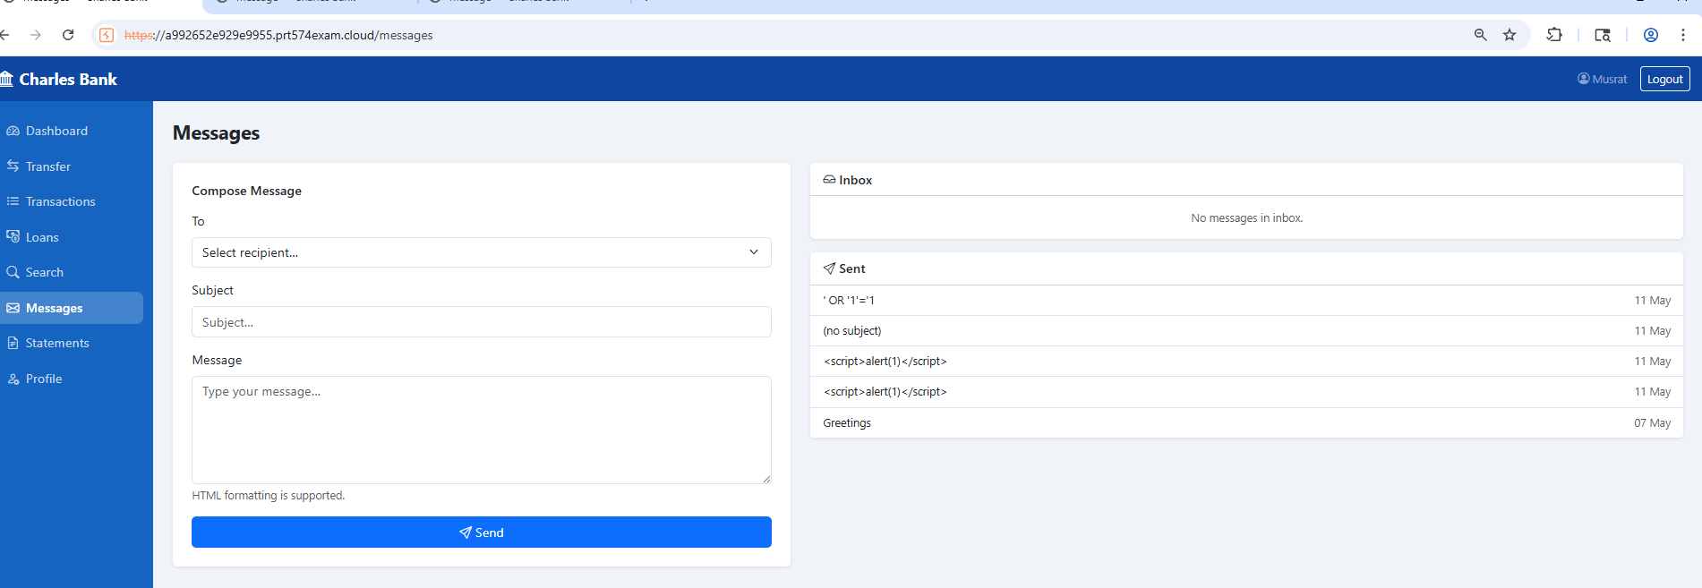

Evidence 2: Message XSS alert

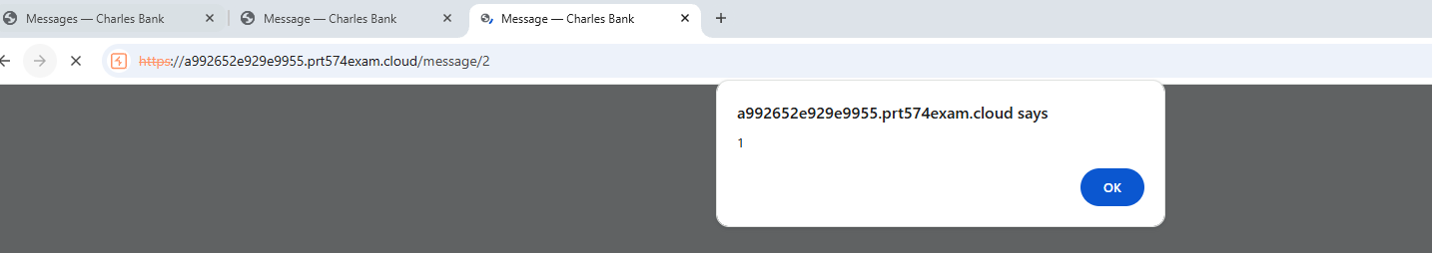

Evidence 3: Access Unauthorized Message ( Meet’s message)

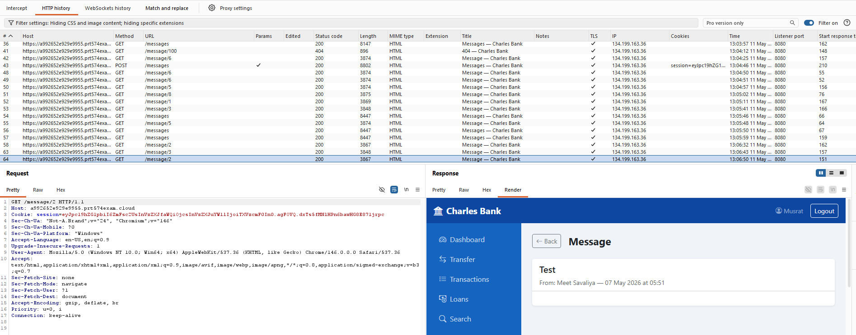

Actions taken
- Logged into the Charles Bank website using a valid account
- Opened the messaging functionality
- Confirmed that the inbox was empty
- Modified the message ID value manually in the browser URL
- Accessed unauthorized private messages successfully
References: Authorization Bypass Through User-Controlled Key, Broken Access Control

18. Business Logic (Negative Value Processing in Fund Transfer)

Risk: Critical | Likelihood: Very Likely | Consequence: Major
Description
The Charles Bank fund transfer functionality does not properly validate transaction amounts on the server side. During testing, a negative transfer value:
- -555.00
was submitted using Burp Suite Repeater and processed successfully by the website.
This confirms that the website accepts negative transaction amounts without proper validation, creating a business logic flaw in the transfer process.

Impact
An attacker could:
- Manipulate account balances
- Reverse transfer logic
- Create invalid financial records
- Bypass banking restrictions
- Abuse transfers for unauthorized financial gain
In the Charles Bank system, this could lead to financial fraud and accounting inconsistencies.
Evidence

Evidence 1: Transfer Accepted Criteria

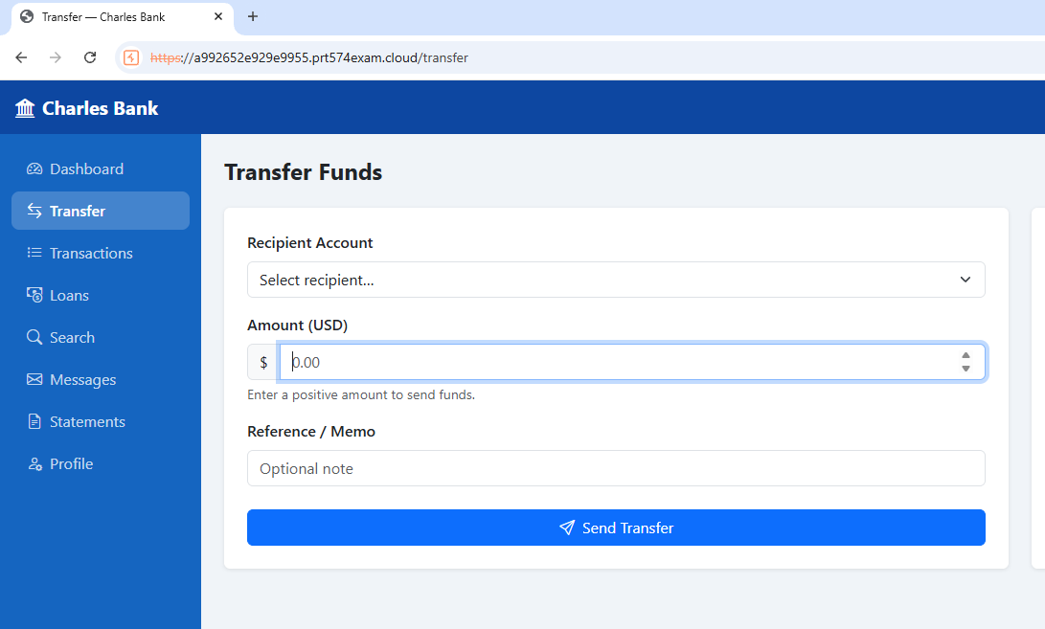
Evidence 2: Negative Transfer Accepted

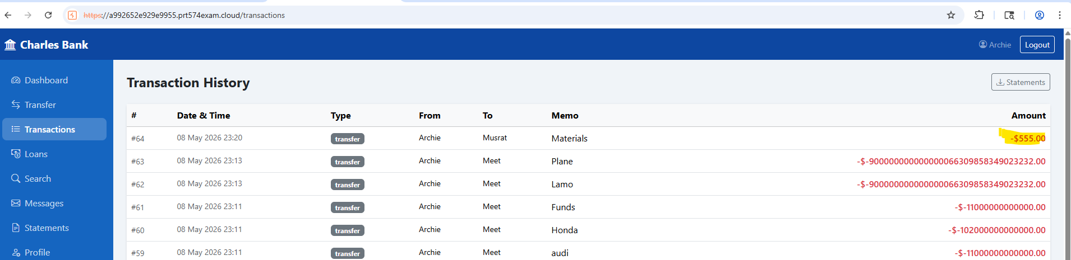

Evidence 3: Burp Suite Negative Transfer Accepted

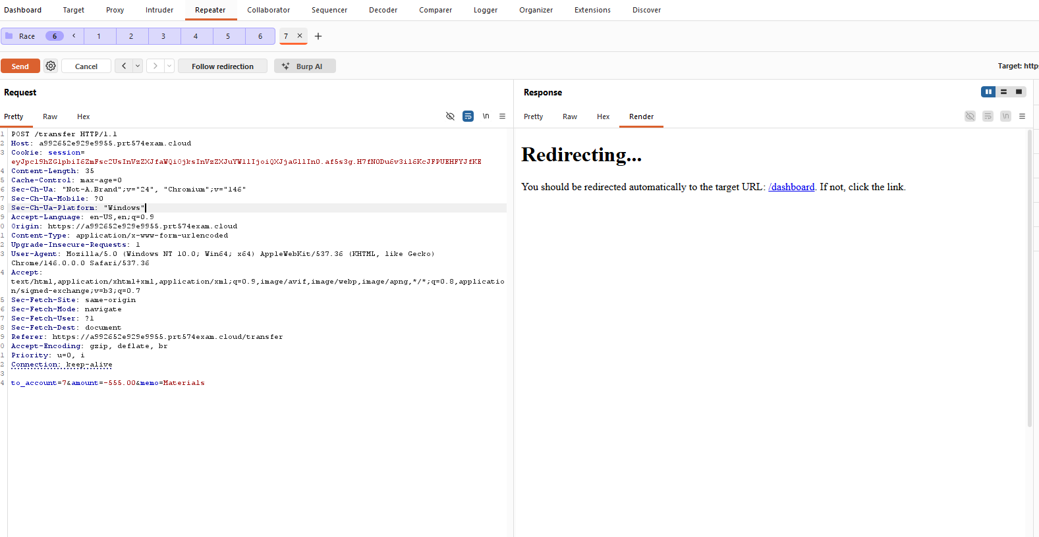

Actions taken
- Opened the fund transfer functionality
- Entered the amount to -555.00
- Submitted the manipulated request successfully
- Verified that the negative transaction appeared in transaction history
References: Broken Access Control and Security Misconfiguration

19. Business Logic (Incorrect Balance Calculation)

Risk: Critical | Likelihood: Very Likely | Consequence: Major
Description
The Charles Bank transaction system does not properly validate negative and malformed currency values. During testing, the website accepted invalid transaction values such as:
- -$-45.00
- +$-15.00
- -$-100000000000000000.00
- +$0.00
These invalid values were used in account balance calculations and caused incorrect balances such as: $100000000000001584.00
This confirms weaknesses in transaction validation and financial calculation logic.

Impact
An attacker could:
- Manipulate account balances
- Create incorrect financial records
- Cause accounting inconsistencies
- Exploit transaction calculation errors
In the Charles Bank system, this could lead to financial fraud and loss of trust in the platform.

Evidence
Evidence 1: Available balance and Transactions

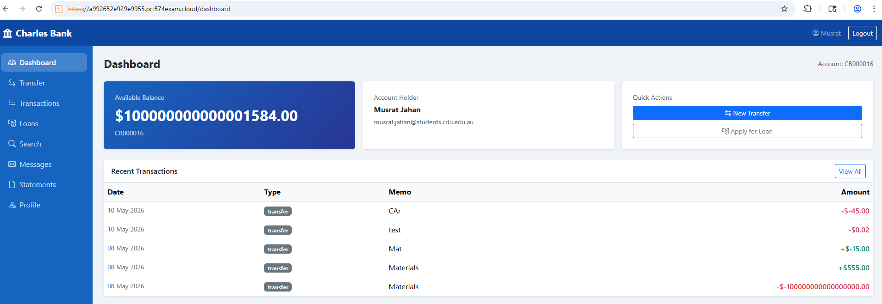

Evidence 2: All Transactions List

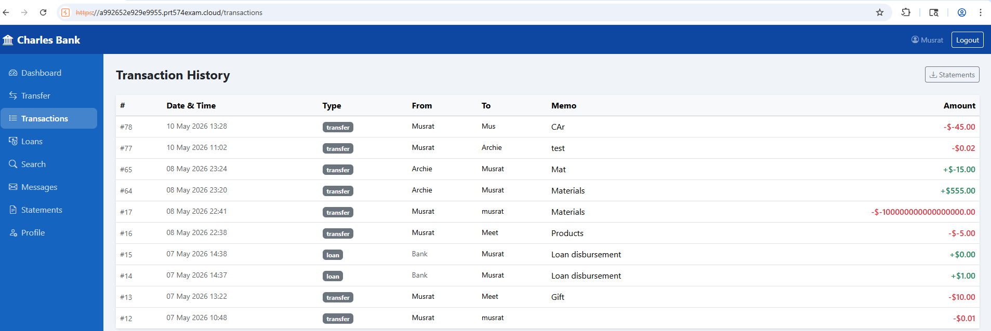
Actions taken
- Opened the fund transfer functionality
- Intercepted requests using Burp Suite
- Modified transaction amounts to malformed and negative values
- Submitted manipulated requests successfully
- Verified incorrect balance calculations and transaction records
References : Business Logic Vulnerabilities

20. Business Logic (Integer Overflow and Improper Input Validation in Transaction system)

Risk: Critical | Likelihood: Very Likely | Consequence: Major
Description
The Charles Bank transaction system contains improper input validation and numeric handling weaknesses in the transfer and deposit functionalities. During testing, extremely large transaction values were submitted using Burp Suite Repeater, and the website accepted them successfully.
Examples of accepted values:-$10200000000000.00
When larger values were submitted, the website generated corrupted transaction outputs such as:-$900000000000000066309858349023232.00
This confirms failures in numeric validation, integer overflow protection, and financial calculation handling.
Impact
An attacker could:
- Manipulate transaction amounts
- Generate invalid balances
- Corrupt financial records
- Cause accounting errors
- Trigger backend calculation failures
In the Charles Bank system, this could lead to financial fraud and data corruption.
Evidence
Evidence 1: Large amount of Transaction Values Accepted

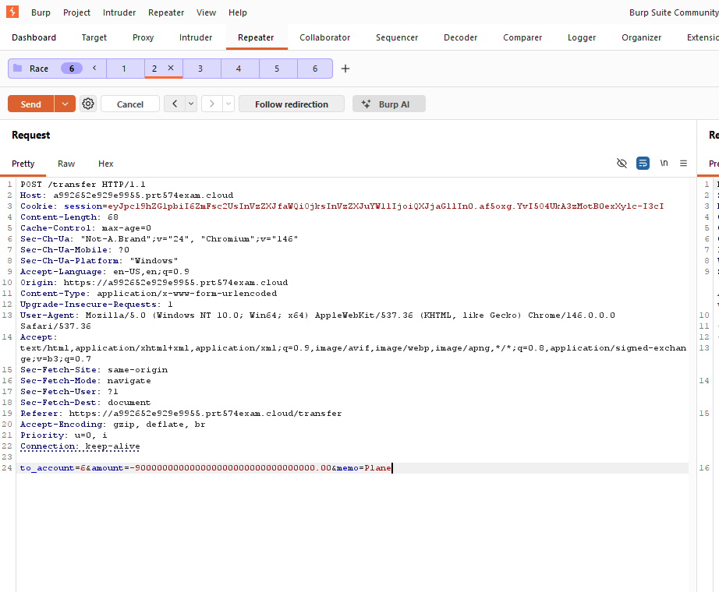

Evidence 2: Integer Overflow Values

Evidence 3: Mismatched values
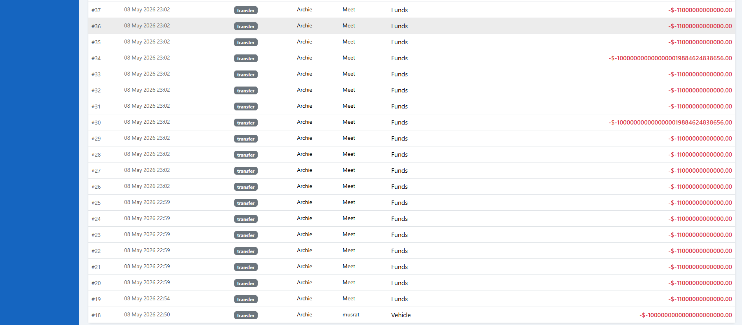
These large number can’t calculate in calculator, there is no pattern

Actions taken
- Modified the transaction amount with extremely large values.
- Submitted manipulated requests to the server.
- observed corrupted transaction records in transaction history
References: Business Logic Flaw and Integer Overflow Vulnerability

21. Business Logic(Improper Input Validation in Loan system)

Risk: Critical | Likelihood: Very Likely | Consequence: Major
The Charles Bank loan functionality contains business logic and input validation weaknesses. During testing, client-side restrictions were bypassed using Burp Suite Repeater, allowing invalid and extremely large loan amounts to be submitted successfully.
The website accepted values such as:
- 0.00
- 0.05
- 0.008
- 200000000000000000000000000.00
Some small decimal values were incorrectly rounded to $0.01, while extremely large values were changed and displayed incorrectly due to numeric precision or integer overflow issues.
The website also showed inconsistencies between loan approval messages and loan history records.

Impact
An attacker could:
- Bypass minimum loan restrictions
- Submit invalid or manipulated loan amounts
- Cause financial calculation errors
- Trigger integer overflow issues
- Manipulate banking records and balances
- Create inconsistent loan and transaction records
In the Charles Bank system, this could lead to financial fraud and data integrity issues.

Evidence

Evidence 1: Loan amount criteria
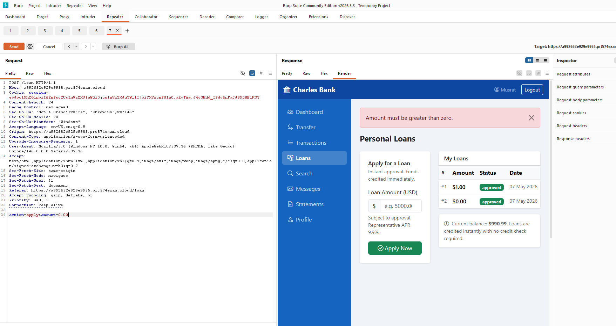

Evidence 2: Loan amount 0.00 accepted

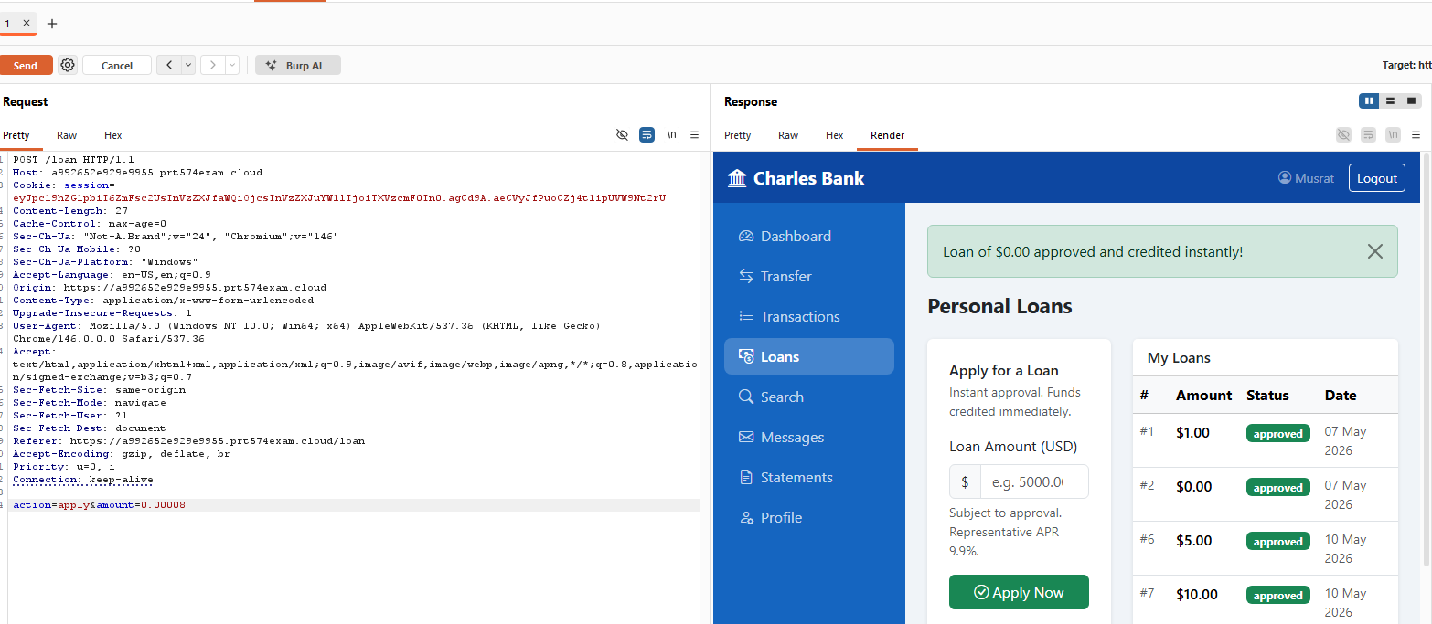

Evidence 3:
- Values 0.00899 (something) were rounded and displayed as $0.01

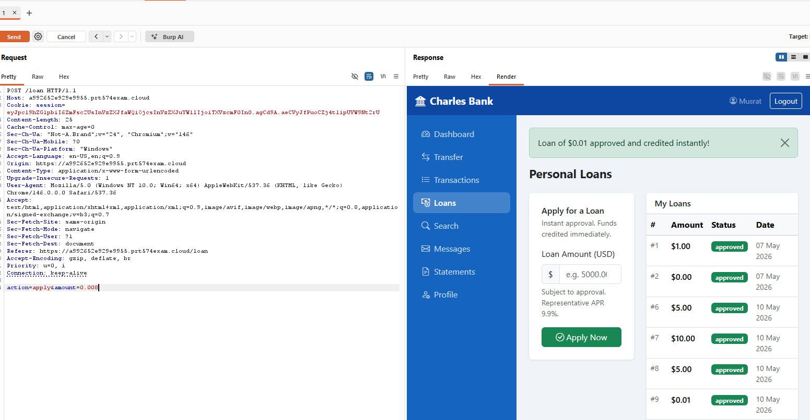

Evidence 4: Large amount Loan Accepted
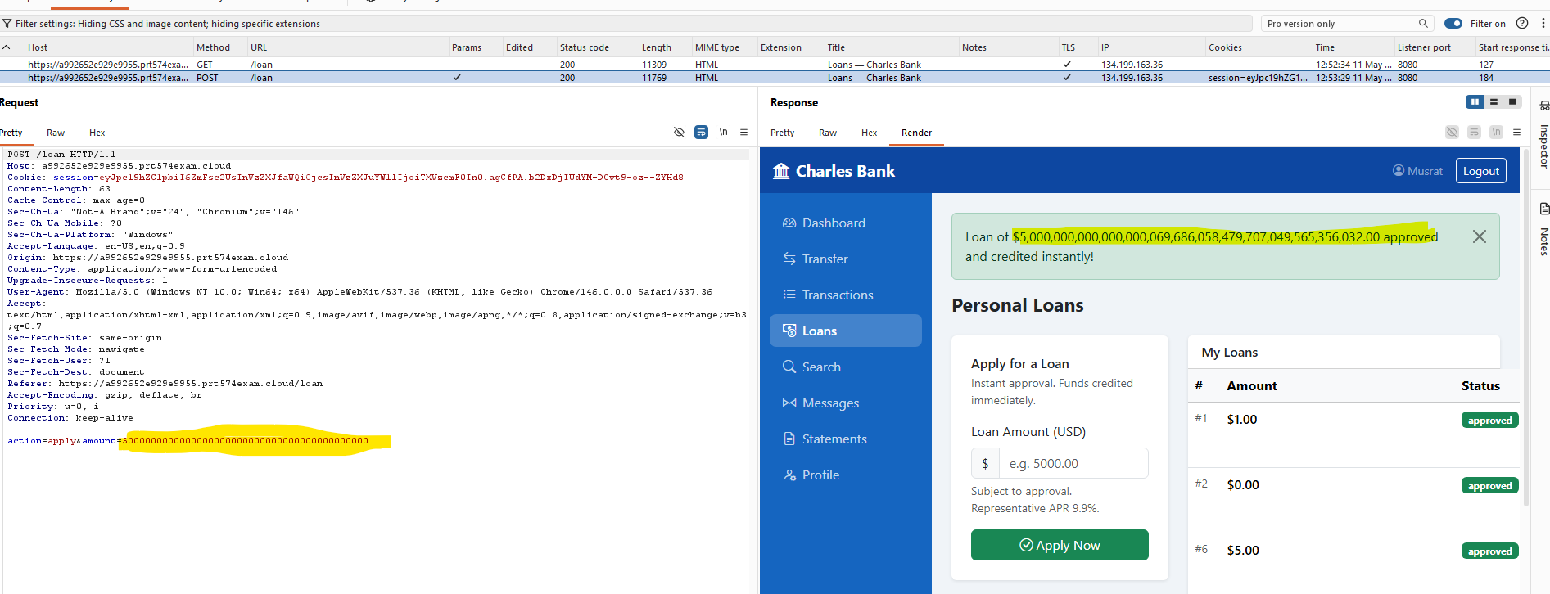
Evidence 5 : Loan list/history did not directly store or display the same approved amount

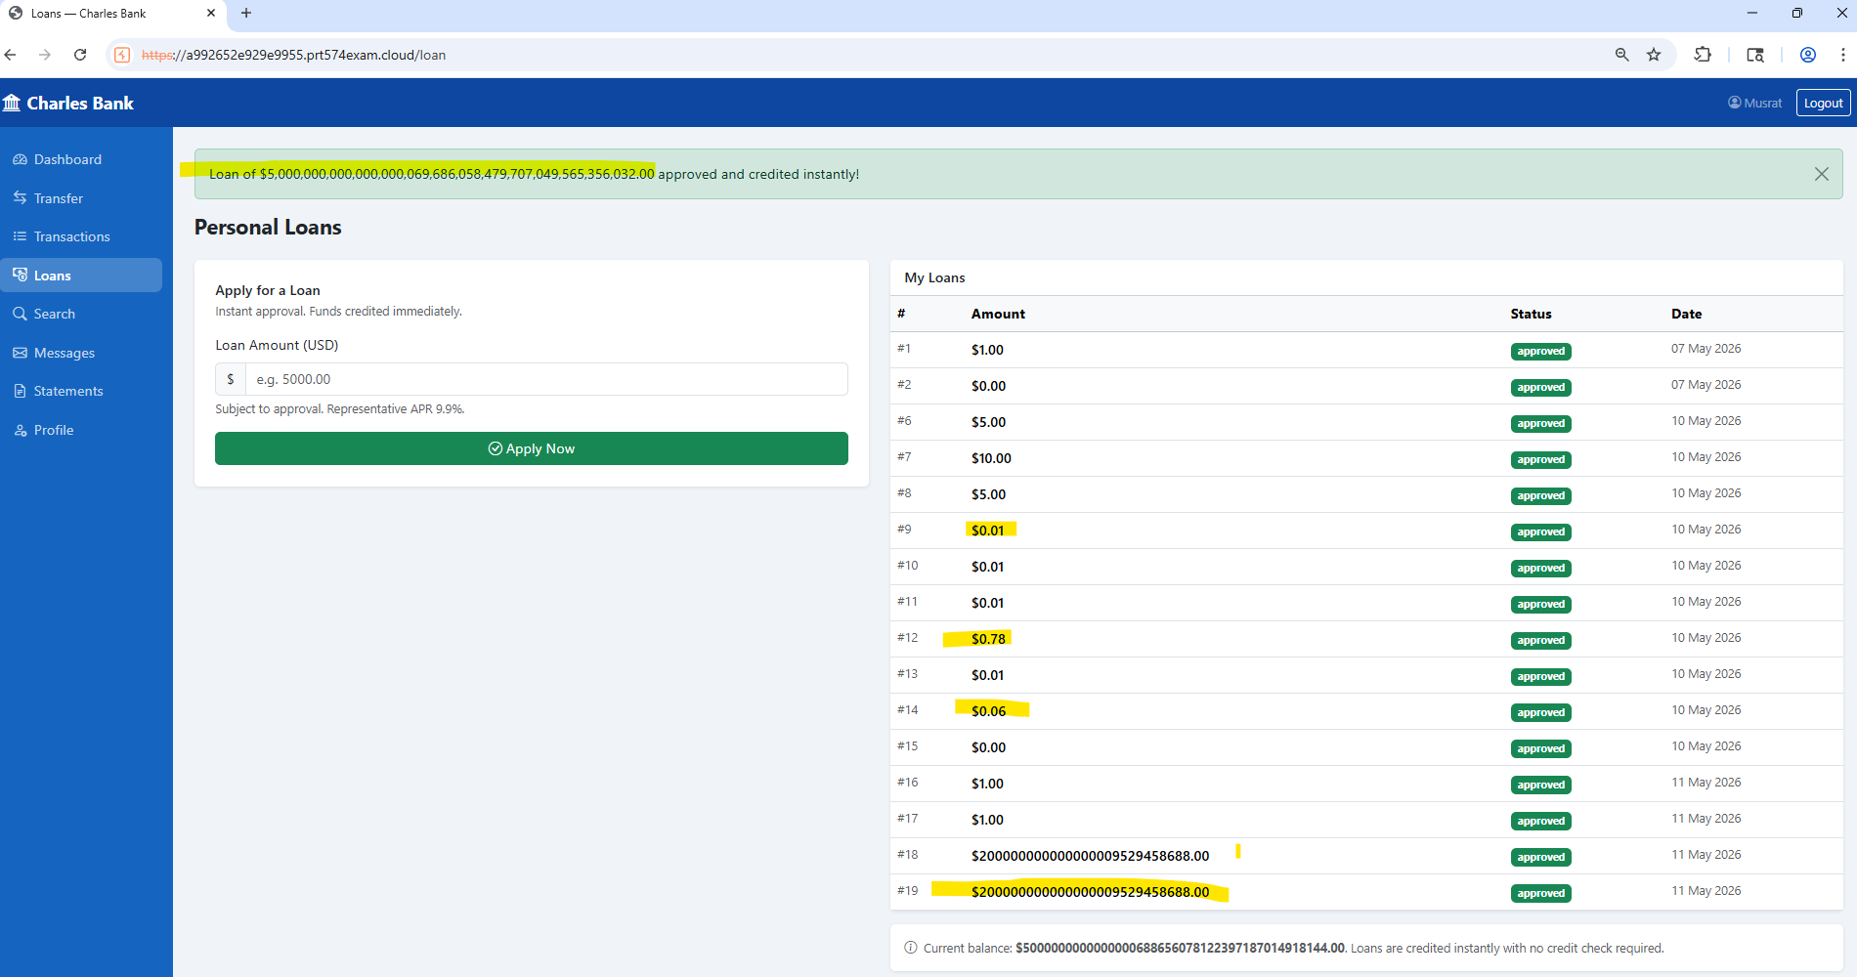

Evidence 6: Large amount is not shown as it is, it’s number handling bug

Actions taken
- Modified loan amount values in Burp Suite Repeater
- Submitted invalid and oversized loan values
- Observed successful processing and inconsistent website behaviour
References: Broken Access Control and Security Misconfiguration

22. Session Management (Improper Session Handling and Access to login Pages While Logged In)

Risk: High | Likelihood: Likely | Consequence: Moderate
Description
The Charles Bank web website contains improper session handling and inconsistent authentication state management. During testing, after logging into User Musrat’s account, opening a new browser tab automatically reused the active authenticated session.
While still logged in as User Musrat, the website continued allowing access to:
- Homepage, Login page, Registration page, Account creation page
This confirms that the website does not properly separate authenticated and unauthenticated user states.

Impact
An attacker could:
- Reuse active authenticated sessions
- Access login and registration functions while authenticated
- Cause session confusion or account misuse
- Increase security risks on shared devices
In the Charles Bank system, this could lead to unauthorized access and session management issues.
Evidence
Evidence 1: Session Reuse Across Tabs

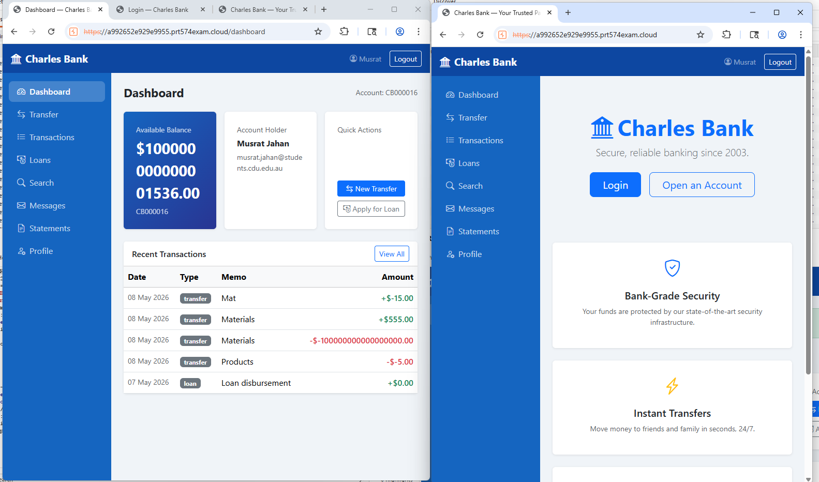

Evidence 2: Burp Suite

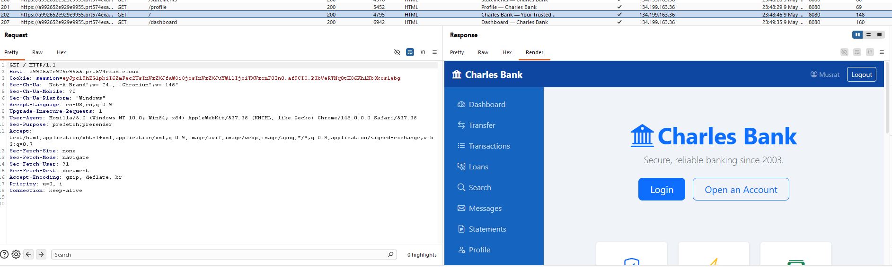

Evidence 3: Access to Public Authentication Pages While Logged In

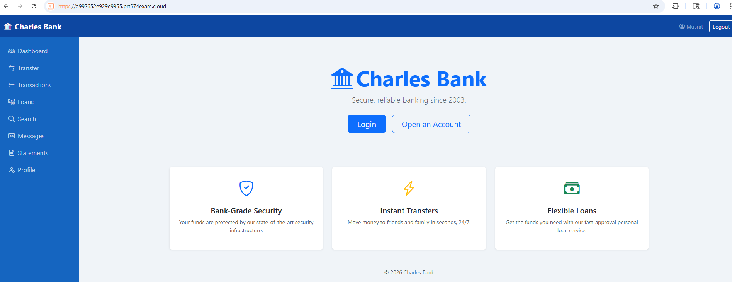

Evidence 4: Inconsistent Authentication State

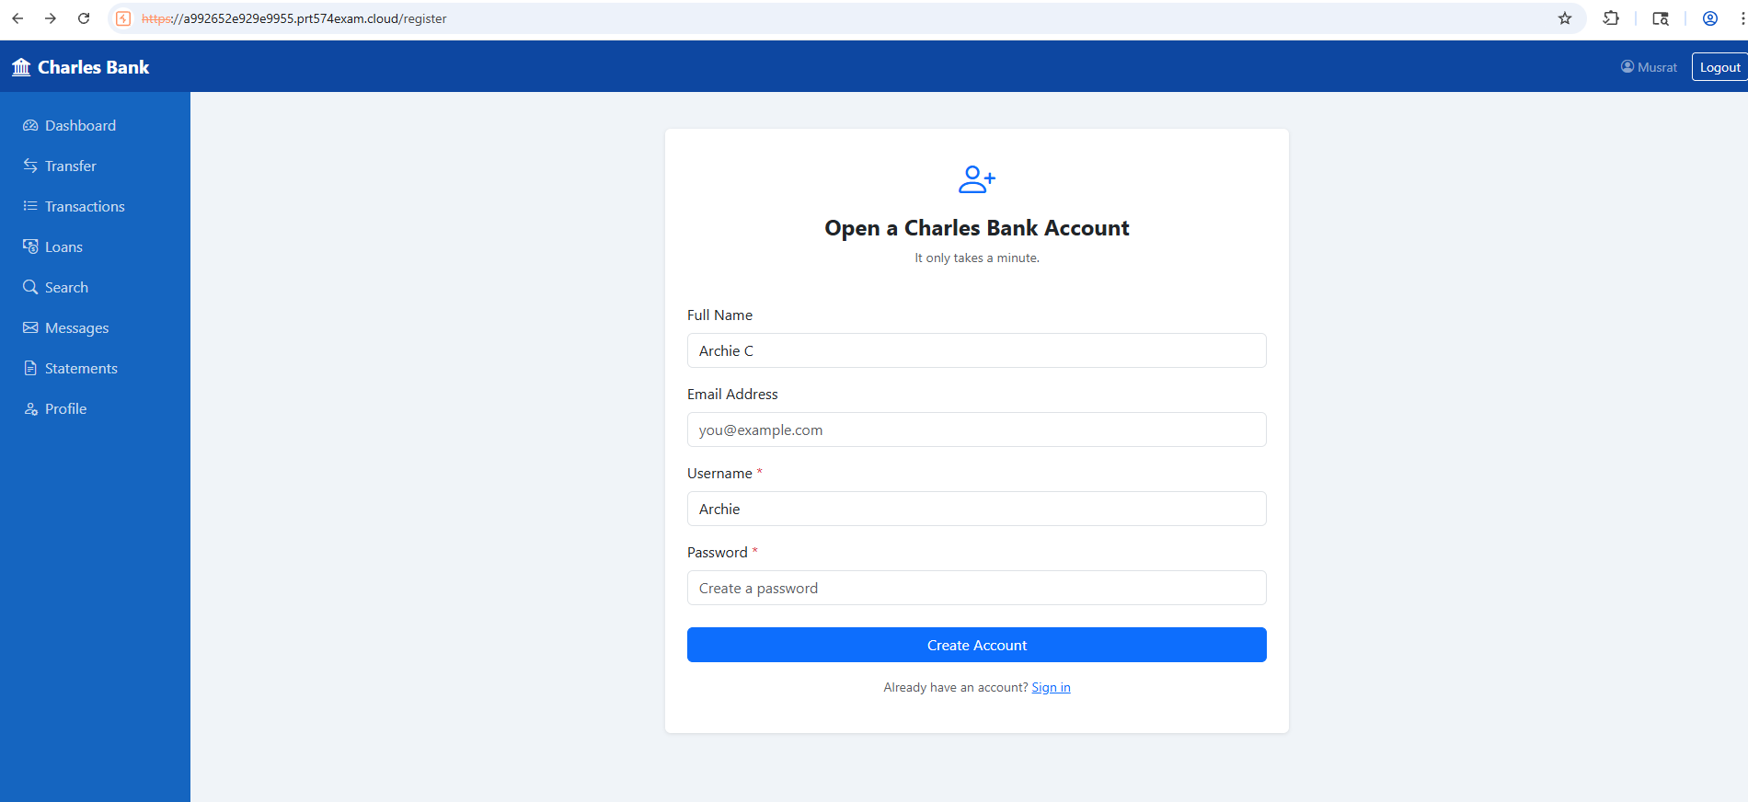

Evidence 5: New account Archie C opened while Musrat is logged in

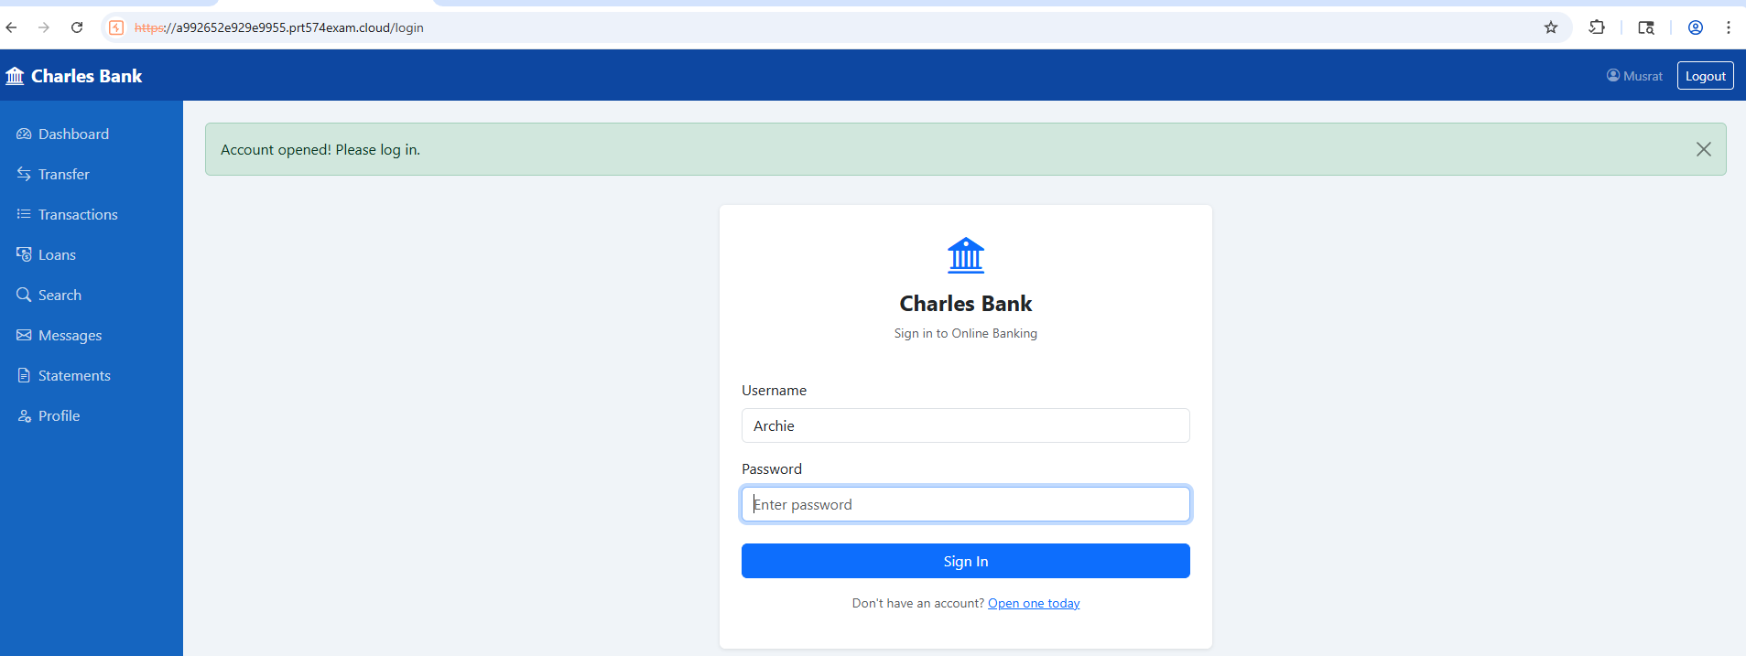

Actions taken
- Logged into the Charles Bank website using a valid account
- Opened a new browser tab & accessed the website URL directly
- Verified that the session remained authenticated
- Opened login and registration pages while still logged in
References: Authentication Failures & Session Management cheat

23. Session Management (Session Persistence Across Browser Windows)

Risk: Medium | Likelihood: Likely | Consequence: Moderate
Description
The Charles Bank web website maintains authenticated sessions across multiple browser windows and tabs without requiring re-authentication. During testing, after logging into the website in one Chrome window, a new browser window was opened and the website URL was accessed directly. The new window automatically reused the active authenticated session and provided access to the logged-in account.
This indicates weak session handling and missing session validation controls.
Impact
An attacker or unauthorized user could:
- Access authenticated accounts without entering credentials
- View sensitive banking information
- Perform unauthorized transactions
- Reuse active sessions on shared or public devices
In the Charles Bank system, this increases the risk of unauthorized account access.
Evidence
Evidence 1: Session Reuse Across Windows

Evidence 2: Burp Suite

Actions taken
- Opened the Charles Bank website in Google Chrome
- Logged into a valid user account
- Opened a new browser window
- Accessed the website URL directly
- Verified that the authenticated session remained active
- Confirmed that no additional login was required
References: Identification and Authentication Failures

24. Directory Traversal

Risk: Critical | Likelihood: Very Likely | Consequence: Major
Description
The Charles Bank website is vulnerable to Directory Traversal in the account statement download functionality. During testing, the payload: ../../etc/passwd
It was entered into the input field, and the website downloaded the sensitive /etc/passwd file from the server. This vulnerability exists because the website does not properly validate or sanitize user input before processing file download requests.
Impact
An attacker could exploit this vulnerability to:
- Access sensitive server files
- Obtain system usernames and account information
- Gather server and website details
- Potentially access configuration files or credentials
In the Charles Bank system, this could lead to serious data exposure and server compromise.

Evidence
Evidence 1: statement downloaded

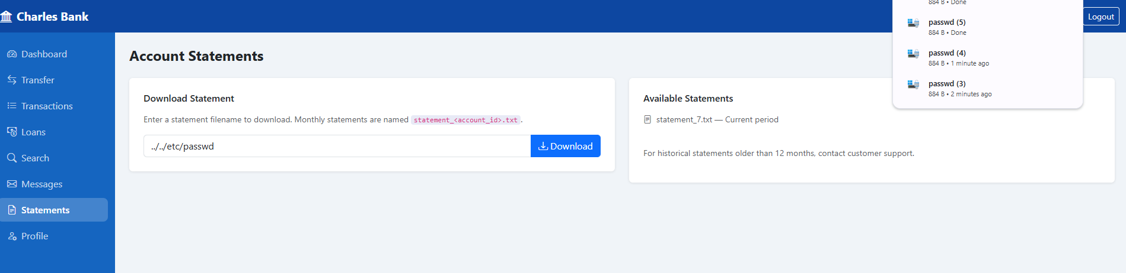

Evidence 2: Statement downloaded with password file
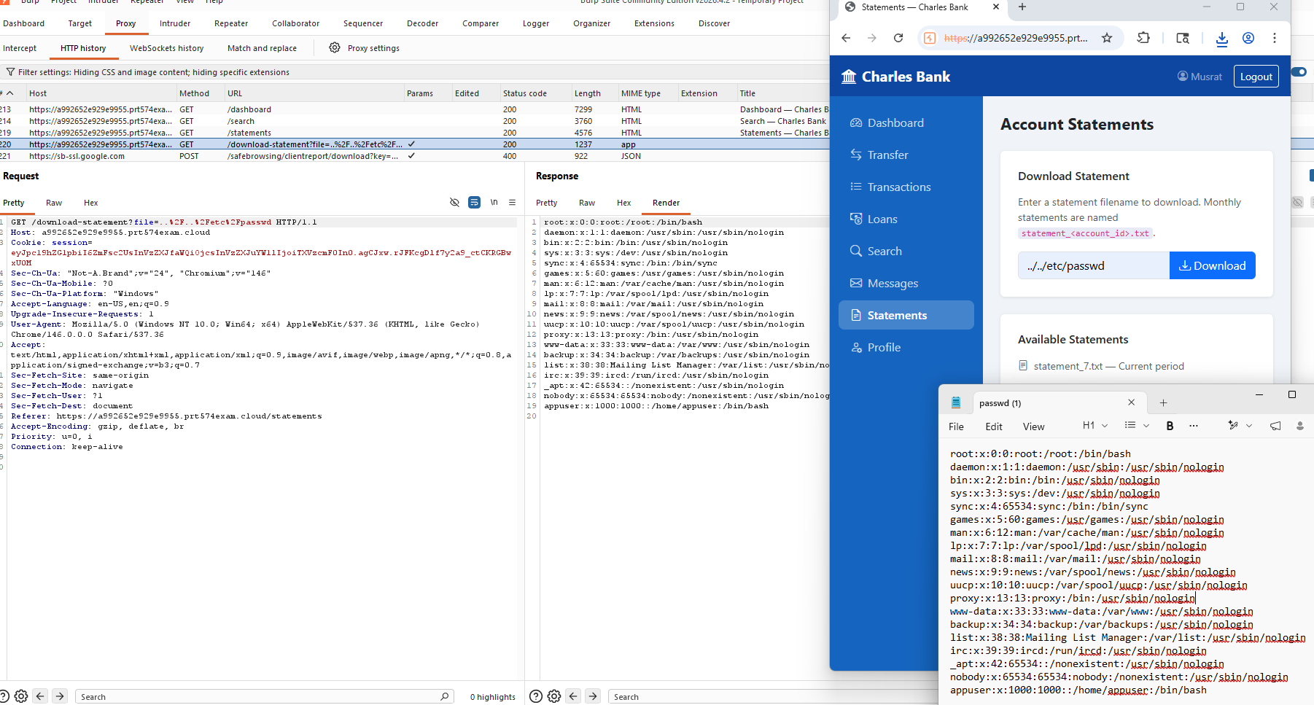

Actions taken
- Tested the statement download functionality
- Entered directory traversal payloads into the input field
- Verified unauthorized access to sensitive server files

References : Path Traversal

References:

Charles Bank 2003, S126 PRT574 Security Assessment in Software Development, Charles Darwin University, https://a992652e929e9955.prt574exam.cloud/
Grammerly n.d., Grammar Checker, https://app.grammarly.com/
OpenAI 2023, ChatGPT (version GPT-3.5), Search, https://chatgpt.com/
PortSwigger n.d., Web Security Academy, https://portswigger.net/web-security/all-labs
PortSwigger n.d., Burp Suite Community Edition, https://portswigger.net/burp/communitydownload

Appendices

Appendix A – Risk Matrix

Consequence
Likelihood |  | Insignificant | Minor | Moderate | Major | Catastrophic
Likelihood | Very Likely | Low | Medium | High | Critical | Critical
Likelihood | Likely | Low | Low | Medium | High | Critical
Likelihood | Possible | Informational | Low | Medium | High | High
Likelihood | Unlikely | Informational | Low | Low | Medium | High
Likelihood | Very Unlikely | Informational | Informational | Low | Medium | Medium

Appendix B – Finding 22 Integer Value finding pattern

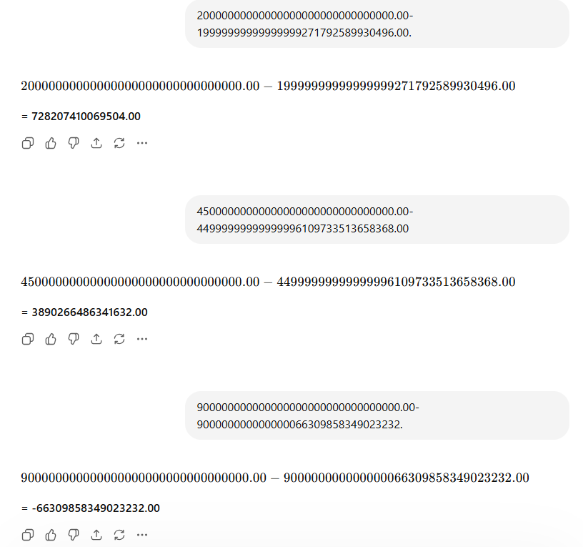

Appendix C – Grammerly

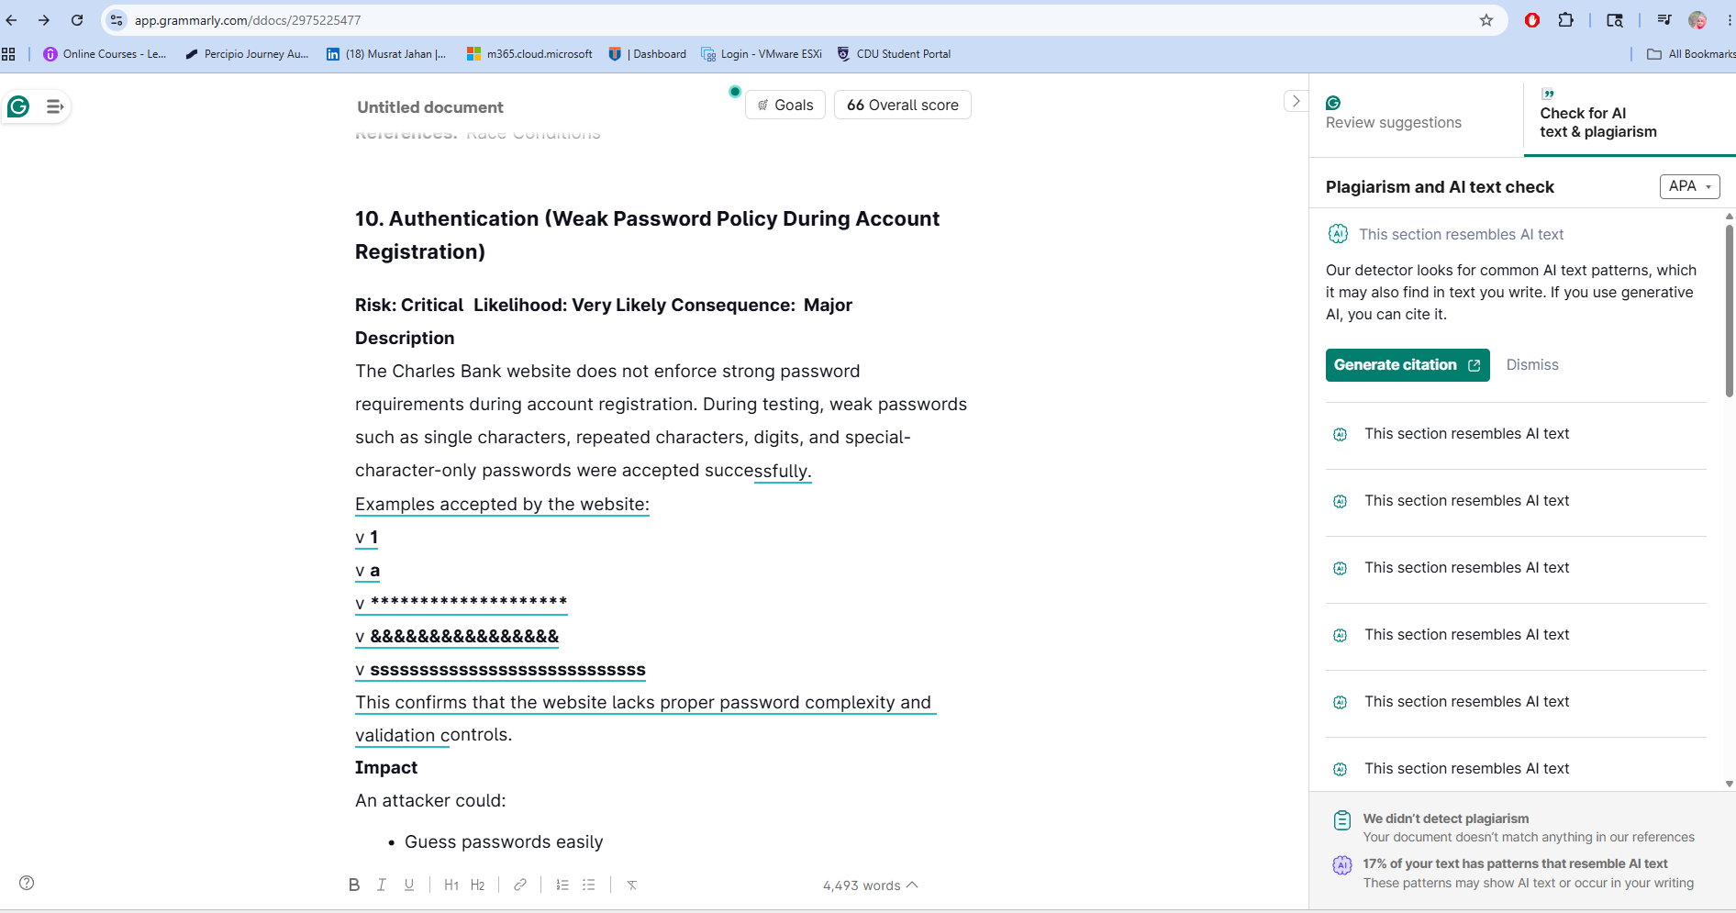
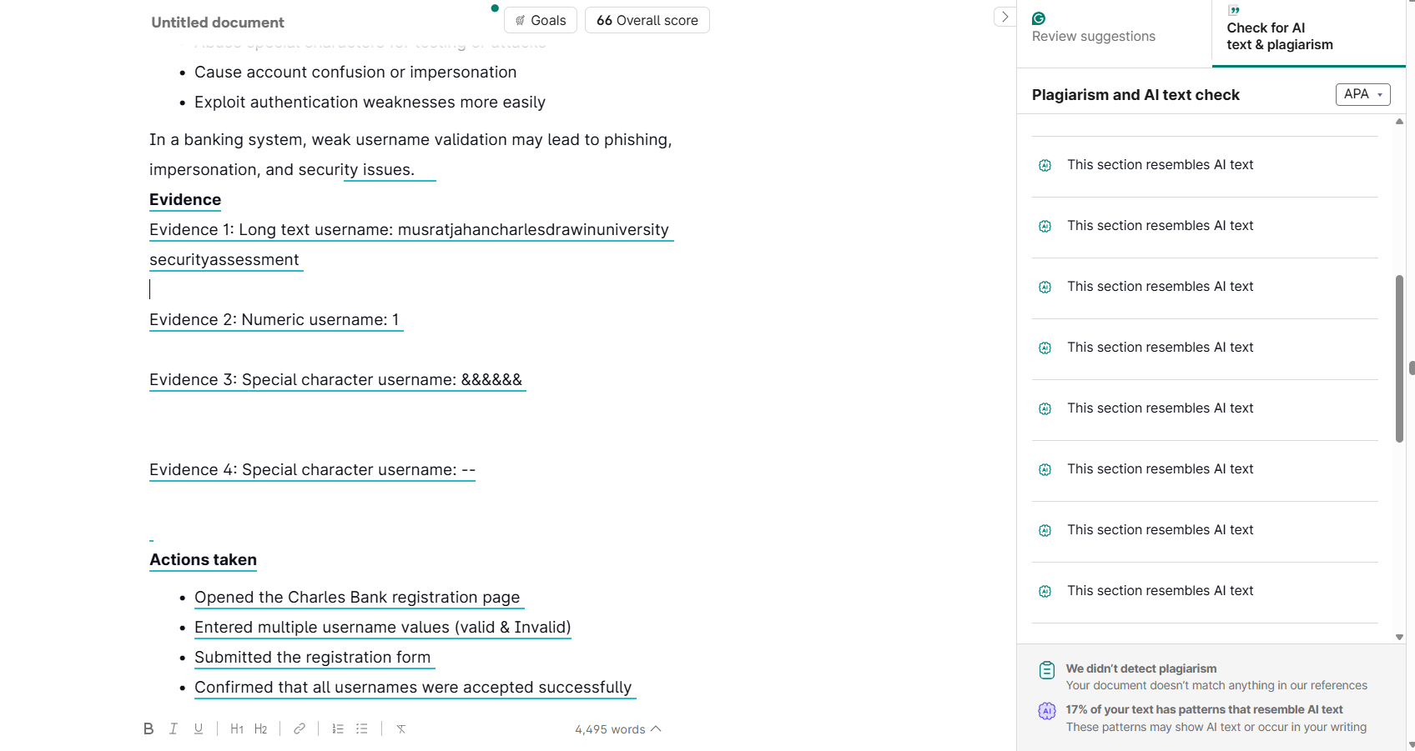

Appendix D – Turnitin



